

FINAL YEAR PROJECT INTERIM REPORT

FYP01-SE-T2530-0073

AI-Powered Smart RSS News Reader with Translation, Summarization, and Enhanced Web Handling

1211106818

LEE XIANG ZE

Bachelor’s in computer science with a Specialization in Software Engineering

February 2026
FYP01-SE-T2530-0073

            - AI-Powered Smart RSS News Reader with Translation, Summarization, and Enhanced Web Handling

BY

1211106818
LEE XIANG ZE

PROJECT INTERIM REPORT SUBMITTED IN PARTIAL FULFILMENT OF THE

REQUIREMENT FOR THE DEGREE OF

Bachelor’s in computer science with a Specialization in Software Engineering

in the

Faculty of Computing and Informatics

MULTIMEDIA UNIVERSITY
MALAYSIA

February 2026

Copyright
© <2026> Universiti Telekom Sdn. Bhd. ALL RIGHTS RESERVED.

Copyright of this report belongs to Universiti Telekom Sdn. Bhd. as qualified by Regulation 7.2 (c) of the Multimedia University Intellectual Property and Commercialisation Policy. No part of this publication may be reproduced, stored in or introduced into a retrieval system, or transmitted in any form or by any means (electronic, mechanical, photocopying, recording, or otherwise), or for any purpose, without the express written permission of Universiti Telekom Sdn. Bhd. Due acknowledgement shall always be made of the use of any material contained in, or derived from, this report.

Declaration

I hereby declare that the work has been done by myself and no portion of the work contained in this report has been submitted in support of any application for any other degree or qualification of this or any other university or institution of learning.


____________________
Name of candidate: LEE XIANG ZE
Faculty of Computing & Informatics
Multimedia University
Date: 11: 02: 2026

Acknowledgements

First and foremost, I would like to express my deepest gratitude to my supervisor, Assoc. Prof. Dr. Chai Ian, for his invaluable guidance, patience and technical insights throughout the development of this project. His expertise helped shape the objectives and requirements of this AI-Powered Smart RSS News Reader.

I would also like to extend my sincere thanks to the Faculty of Computing and Informatics and Multimedia University (MMU) for providing the academic environment and resources necessary to conduct this project.

A special note of appreciation goes to the previous developers of this application. As this project is inherited, their foundational work provided the essential framework that allowed me to identify technical deficiencies and implement advanced AI enhancements.

Furthermore, I am grateful to Groq for providing API access that powers the translation and summarization features of this system.

Lastly, I want to thank my family and friends for their unwavering emotional support and encouragement during the challenging phases of this Final Year Project. This milestone would not have been possible without their presence in my life.

LEE XIANG ZE February 2026

Abstract
In the era of Web 2.0, the exponential growth of online content has made gathering valuable information a time-consuming process. This project focuses on the design and development of mobile-based RSS (Really Simple Syndication) news reader intended to aggregate the latest updates from multiple sources into a single interface.
To address the limitations of traditional feed readers, the application integrates advanced Artificial Intelligence features to enhance the content accessibility. The system will use LLM to provide high-quality translation and utilize AI-driven summarization to condense articles while automatically cleaning distracting content such as advertisements and social media widgets. Furthermore, the design supports offline web browsing to conserve bandwidth. It also features Text-to-speech (TTS) continuity to maintain audio playback, including Bluetooth connectivity. By combining efficient backend data retrieval with intelligent content processing, this solution undeniably offer a streamlined, resource-efficient method for users to access personalized news and video feeds.

Table of Contents

Copyright ii
Declaration iii
Acknowledgements iv
Abstract v
Table of Contents vi
List of Tables x
List of Figures xi
List of Abbreviations/Symbols xii
List of Appendices xiii
Chapter 1 : Introduction 1
1.1 Overview 1
1.2 Problem Statement 1
1.3 Objectives 2
1.4 Scope 3
1.5 Limitation 3
1.6 Methodology 3
1.6.1 Literature Review and Requirement Gathering 4
1.6.2 System Analysis and Design 4
1.6.3 Iterative Implementation Phase 4
1.6.4 Testing, Validation, and Deployment 5
1.7 Target Audience 5
1.8 Summary 6
Chapter 2 : Literature Review 7
2.1 Overview 7
2.2 Evolution and Mechanics of RSS Technology 7
2.3 Intelligent Content Aggregation and Adaption 7
2.3.1 Content Adaption and AI Integration 7
2.4 Artificial Intelligence in News Aggregation 8
2.4.1 Translation and Summarization 8
2.5 Psychosocial Impacts and Ethical Algorithms 8
2.5.1 The Neurophysiology of Engagement 8
2.5.2 Polarization and Filter Bubbles 9
2.6 Human-Computer Interaction and Cognitive Constraints 9
2.6.1 Strategies for Multitasking and Chunking 9
2.6.2 Flow and Perceived Usability 10
2.6.3 Content Adaptation and Auditory Consumption 10
2.7 Summary 10
Chapter 3 : Requirement Analysis 11
3.1 Overview 11
3.2 Techniques 11
3.2.1 Justification 11
3.2.2 Interview 11
3.3 Requirement 15
3.3.1 WebView and Display Enhancements 15
3.3.2 LLM-Powered Translation 15
3.3.3 AI Content Optimization 15
3.3.4 Robust Page Loading and Recovery 16
3.3.5 Persistent Audio and State Management 16
3.3.6 UI/UX Responsiveness 16
3.3.7 Extended Content Sourcing 17
3.3.8 General System Requirements 17
Chapter 4 : System Design 18
4.1 Overview 18
4.2 Rich Map Diagram 18
4.3 UML Diagram 19
4.4 Use Case Diagram 20
4.5 Activity Diagram 21
4.5.1 Change Settings 21
4.5.2 Load App State 22
4.5.3 Save App State 23
4.5.4 Add New Feeds 24
4.5.5 Edit Feed 25
4.5.6 Refresh Feed 26
4.5.7 Delete Feed 27
4.5.8 View News Article 28
4.5.9 Translate/Summarize News Article 29
4.5.10 Share News Article 30
4.5.11 Text-to-speech (TTS) 31
4.5.12 Chatbot 32
4.6 User Interface Design 33
4.6.1 Main Page 33
4.6.2 Non-extracted News Article 34
4.6.3 Extracted News Article 35
4.6.4 Translated News Article 36
4.6.5 Summarized News Article 37
4.6.6 Text-to-speech (TTS) 38
4.6.7 Chatbot 39
4.6.8 Night Mode 40
4.6.9 Toolbar 42
4.6.10 Settings 43
4.6.11 Add New Feeds 44
4.6.12 Manage Feeds 46
4.6.13 Feed Settings 47
4.6.14 Help 48
Chapter 5 : Implementation Plan 49
5.1 Gantt Chart 49
5.2 Overview 49
5.3 Implementation phase 49
5.3.1 Stage 1: Database architecture (1 month) 49
5.3.2 Stage 2: AI integration (2 weeks) 50
5.3.3 Stage 3: Stabilize existing features (1.5 months) 50
5.3.4 Stage 4: Implement new features (2 months) 50
5.4 Testing phase 50
5.4.1 Unit Testing 50
5.4.2 Integration Testing 50
5.4.3 System Testing 51
5.4.4 User Acceptance Testing (UAT) 51
5.5 Deployment phase 51
5.5.1 Application Hardening and Optimization 52
5.5.2 Play Store Submission Preparation 52
5.3.3 Launch and Post-Deployment Monitoring 52
Chapter 6 : Conclusion 53
Reference i
Appendix A iii
Appendix B iv
Appendix C xiv
Appendix D xv

List of Tables
Table 1 Interview 1 12

List of Figures
Figure 4.1 Rich Map Diagram 18
Figure 4.2 UML Class Diagram 19
Figure 4.3 Use Case Diagram 20
Figure 4.4 Activity Diagram for Settings 21
Figure 4.5 Activity Diagram for Load State 22
Figure 4.6 Activity Diagram for Add new feed 24
Figure 4.7 Activity Diagram for Edit feed 25
Figure 4.8 Activity Diagram for Refresh feed 26
Figure 4.9 Activity Diagram for Delete feed 27
Figure 4.10 Activity Diagram for View article 28
Figure 4.11 Activity Diagram for Translate/Summarize article 29
Figure 4.12 Activity Diagram for Sharing article 30
Figure 4.13 Activity Diagram for Text-to-speech 31
Figure 4.14 Activity Diagram for Chatbot 32
Figure 4.15 Main Page 33
Figure 4.16 Non-extracted content 34
Figure 4.17 Extracted content 35
Figure 4.18 Translated content 36
Figure 4.19 Summarized content 37
Figure 4.20 TTS 38
Figure 4.21 Chatbot 39
Figure 4.22 Night content 40
Figure 4.23 Night toolbar 41
Figure 4.24 Toolbar 42
Figure 4.25 Settings 43
Figure 4.26 Add feeds 44
Figure 4.27 Login prompt 45
Figure 4.28 Manage feeds 46
Figure 4.29 Feed settings 47
Figure 4.30 Help 48
Figure 5.1 Gantt chart 49

List of Abbreviations/Symbols
Abbreviation | Full Term
AI | Artificial Intelligence
API | Application Programming Interface
APK | Android Package Kit
CRUD | Create, Read, Update, Delete
DAO | Data Access Object
FCI | Faculty of Computing and Informatics
FYP | Final Year Project
LLM | Large Language Model
ML | Machine Learning
MMU | Multimedia University
MVVM | Model-View-ViewModel
NLP | Natural Language Processing
OWeB | Offline Web Browsing
RSS | Really Simple Syndication
SDK | Software Development Kit
TTS | Text-to-Speech
UI | User Interface
UML | Unified Modelling Language
URL | Uniform Resource Locator
UX | User Experience
XML | Extensible Markup Language

List of Appendices
Appendix A: Project Gantt Chart
An updated timeline showing the literature review, design, implementation, testing and deployment phases.
Appendix B: FYP 1 Meeting Logs
Soft copy of six (6) meeting log sheets signed by supervisor.
Appendix C: Turnitin Similarity Index Page
The official report showing an overall similarity index.
Appendix D: Interview Questions
The questions asked for the interview session.

: Introduction

1.1 Overview
In this modern digital landscape, information consumption is increasingly dominated by algorithm-driven platforms such as social media (Facebook, X, TikTok) and commercial news aggregators (Google News, Apple News). While these platforms offer convenience, they often trap users in “filter bubbles”. These platforms prioritize engagement over quality, resulting in user privacy compromising through extensive data tracking. On the other hand, RSS (Really Simple Syndication) technology offers a compelling alternative by allowing users to aggregate digital content such as blogs and news into a single interface without algorithmic interference.
In this case, this project focuses on developing a sophisticated RSS News Reader application for Android, which is the most-used mobile operating system currently. It aims to provide a “calm”, distraction-free reading environment where the user, rather than an algorithm, controlling the information flow at anywhere and anytime.

1.2 Problem Statement
The development of this application is driven by specific technical deficiencies identified in existing solutions including previous version of this specific application.
- Translation Limitations:
Existing translation engines which use on-device translation using Google ML Kit often struggle with the context. This leads to misinterpretation of proper names such as Bajau Laut -> Bajau Sea.

- Navigation and Display Flaws:
Users may experience difficulties interacting with articles, specifically lacking pinch-to-zoon support in WebViews, which hinders accessibility. Moreover, some JavaScript-heavy news sites such as Harian Metro and Astro Awani often fail to load or render correctly.

- Audio Interruptions:
The text-to-speech (TTS) engine lacks continuity. It fails to resume playback correctly after application pauses or screen rotations. It will lose audio focus when competing with external apps like Spotify.

- Content Clutter:
Full articles are often riddled with “Read more” links, paywall prompts and social media widgets that will degrade and interrupt the reading experience.

1.3 Objectives
As the usage of AI becomes more widespread, more AI models are being made available for limited free usage. In this project, Groq will be used as the provider to allow users obtain their own API keys and deal with the payment if they want to unlock better experience to use AI without limitations. Besides, they can also choose the model they want.
One of the objectives of this project is to use the intelligence of AI for better translation. By using ML toolkit from Google, it will just translate the content words by words directly without caring about the context. However, large language models that are used by the current AI models will be able to obtain the whole context of the content and do the translation precisely. Moreover, it can also help to summarize the article in desired length to allow the users to acknowledge about the content in a rapid way to save time.
Apart from that, this application will feature a robust web scrapping module that extracts articles from the websites which have no native RSS feed being provided. Since there are less RSS feeds nowadays, users are allowed to provide a general URL from the news page and the application will deal with the news extraction and treat the news like the RSS feed, with translation and summarization feature using AI.
Lastly, since this project is inherited from previous developers, there are instability and bugs exist in this application. Catching the issues and solving them is also one of the main objectives in this project as responsiveness and stability are one of the most important aspects of a good Android application. Our final goal is to develop an application that is good enough to be uploaded into Play Store and used by the public all around the world.

1.4 Scope
The application is developed for devices running between Android 10 and Android 17. It targets users seeking a privacy-focused, customizable news reading experience. It will also be user-friendly to allow casual users to enjoy the news-reading experience, with TTS and AI features including summarization and translation enabled.

1.5 Limitation
The application is strictly developed for the Android operating system which targets versions between Android 10 and Android 17. It will not be available for iOS or desktop platforms.
The translation and summarization features are dependent on external API connectivity through Groq. Consequently, the performance and response times of these features are subject to network stability and API provider uptime.
While users can provide their own API keys, high-quality translation and summarization are limited by the token limits and usage costs associated with the selected Large Language Model (LLM).
While the application supports a framework for offline web browsing through pre-fetching, initial feed updates, AI processing and the first-time loading of news articles require an active internet connection.
The robust web scraping module may struggle with websites that employ aggressive anti-scraping measures, complex paywalls or highly unconventional JavaScript structures that prevent successful content sanitization.
The Text-to-Speech (TTS) functionality is limited to the voices and languages supported by the user’s default device TTS engine. The application does not provide its own proprietary voice synthesis library.
The accuracy of AI-generated summaries and translations is dependent on the context window of the LLM used. The system may occasionally produce "hallucinations" or inaccuracies typical of generative AI models.

1.6 Methodology
The development of this project follows a modular Android architecture, specifically the Model-View-ViewModel (MVVM) pattern to ensure high maintainability and scalability. The research and development process is executed over a nine-month period across several iterative stages.

1.6.1 Literature Review and Requirement Gathering
A comprehensive literature review is conducted to establish a foundational understanding of RSS technology mechanics and current AI integration trends.
User requirements are gathered through semi-structured interviews with diverse user personas to identify critical pain points in existing news aggregators, such as translation inaccuracies and audio focus issues.

1.6.2 System Analysis and Design
Requirements are analysed to extract actionable implementation tasks, focusing on utility-based AI features.
The system backend is designed first, utilizing the Room persistence library and Data Access Object (DAO) classes to ensure secure data encapsulation.
Technical diagrams including Rich Map, UML Class, Use Case and Activity diagrams are created to visualize the application logic and external API interactions.

1.6.3 Iterative Implementation Phase
- Stage 1: Database Architecture: The inherited database structure is reviewed and updated to support new AI-driven data objects and migration paths.
- Stage 2: AI Integration: New classes are implemented to handle asynchronous API requests to Groq for translation and summarization features.
- Stage 3: Stabilization: Existing bugs from the forked codebase are resolved to ensure overall application responsiveness and stability.
- Stage 4: Feature Implementation: New required functions, such as custom web scraping and enhanced WebView displays, are added while ensuring backward compatibility.

1.6.4 Testing, Validation, and Deployment
The application undergoes rigorous testing, including unit testing, integration testing and User Acceptance Testing (UAT).
Final validation is performed to ensure the similarity index remains 20% before the application is deployed to the Play Store for public use.

1.7 Target Audience
The AI-Powered Smart RSS News Reader is designed for a diverse group of users who seek a more controlled, efficient and personalized news consumption experience. The primary target audiences include:
- Privacy-Conscious Readers: Individuals who wish to escape extensive data tracking prevalent on algorithm-driven platforms like social media and commercial news aggregators.
- International News Consumers: Users who monitor news across multiple languages and require context-aware translations that preserve cultural nuances and proper names better than traditional on-device engines.
- Multitasking Professionals: Individuals who frequently divide their attention between reading and secondary tasks, such as commuting and require robust Text-to-Speech (TTS) continuity with Bluetooth support for "eyes-free" consumption.
- Time-Constrained Information Seekers: Users who need to digest large volumes of information rapidly and rely on AI-driven summarization to condense articles while maintaining the core message.
- Casual Mobile Users: General Android users (running versions 10 to 17) seeking a user-friendly, distraction-free interface that automatically sanitizes content by removing advertisements and social media widgets.
- Niche Blog and Site Followers: Tech-savvy users who follow specific blogs or localized news portals that do not offer native RSS feeds and require a robust web-scraping module to aggregate content.

1.8 Summary
This chapter has established the foundation for the development of the AI-Powered Smart RSS News Reader. It began with an overview of the modern digital landscape, highlighting the limitations of algorithm-driven platforms that prioritizes engagement over quality. The project aims to address specific technical deficiencies identified in existing readers, including context-poor translations, navigation flaws in WebView, audio focus interruptions in Text-to-Speech (TTS) and content clutter from advertisements.

By utilizing Large Language Models (LLMs) via Groq, the project objectives focus on achieving contextually accurate translations and summaries, implementing a robust web scraping module for non-RSS sites and stabilizing the inherited codebase for a production-ready Play Store release. The development follows the MVVM modular architecture, targeting Android 10 to 17 users who seek a privacy-focused, "calm" reading experience. This chapter serves as a roadmap for the subsequent literature review and requirement analysis, which will further detail the technical and psychological gaps addressed by this intelligent and adaptive system.

: Literature Review

2.1 Overview
Traditionally, users were required to visit individual websites one by one to check for updates. The process is time-consuming and inefficient. The RSS has then emerged as a pivotal technology to address this challenge by enabling the aggregation of updates from multiple websites into a single interface. This chapter reviews the evolution of RSS technology, which provides architectural strategies for implementing efficient mobile readers.

2.2 Evolution and Mechanics of RSS Technology
RSS is a content delivery vehicle used to syndicate news and other web content in a standardized XML format. The technology originated from the “push” and “pull” information delivery models. In a traditional “pull” model, the client will need to initiate a request for data. Conversely, “push” technology involves a server delivering information to the user based on the pre-specified preferences. (D. Sharma, 2017)
The standard RSS readers function as the aggregators. They will check user-subscribed feeds for updates and display concise summaries or links. This mechanism allows users to scan headlines quickly without navigating through complex site structures. However, as the volume of feeds increases, simple chronological listing can lead to information overload. This will require more intelligent filtering and ranking mechanisms. (J. Zhou, 2010)

2.3 Intelligent Content Aggregation and Adaption
As the volume of available feeds grows, simple chronological aggregation becomes insufficient and leads to information overload. Consequently, modern RSS readers must evolve from passive display tools into intelligent systems capable of filtering and adapting content.

2.3.1 Content Adaption and AI Integration
Mobile environments impose constraints regarding screen size and network reliability. Frameworks for Offline Web Browsing (OWeB) have been developed to pre-fetch RSS content and stitch it into local templates. This can allow seamless access during intermittent connectivity. (K. Toyama, 2006) This aligns with the modern requirements for mobile readers to detect failed page loads and handle JavaScript-heavy sites by attempting automatic reloads or utilizing AI analysis to determine content integrity. Moreover, adapting content for mobile screens often involves stripping away non-essential elements like advertisements and complex tables to enhance readability. (A. Blekas et al., 2006)

2.4 Artificial Intelligence in News Aggregation
Modern news readers are increasingly moving beyond simple aggregation toward intelligent content processing due to AI trends. This shift involves the use of Natural Language Processing (NLP) and Machine Learning (ML) to enhance user experience.

2.4.1 Translation and Summarization
The globalization of information necessitates robust translation capabilities. Advanced AI models, such as Llama, can provide high-quality translations by using the API call. This can save processing resources as the device does not need to run the AI model itself. (S. Zhou et al., 2023) Additionally, AI-driven summarization is critical for mobile users who prefer concise content. The ability to condense articles into user-defined lengths while preserving key points is a significant advancement over static RSS summaries. Apart from that, AI will be used to clean distracting elements to ensure the content remains focused and readable.

2.5 Psychosocial Impacts and Ethical Algorithms
The design of news algorithms has profound effects on user well-being and social dynamics. It is crucial to distinguish between utility-based aggregation and profit-driven algorithmic curation.

2.5.1 The Neurophysiology of Engagement
Social media platforms utilize algorithms optimized for engagement. It is often exploiting the brain’s mesolimbic reward system. The “dopamine loop”, driven by variable rewards such as likes and endless scrolling. This can foster addictive behaviors, particularly among adolescents. Research has indicated that frequent engagement with these algorithmic loops alters dopamine pathways and can impair executive functions in the prefrontal cortex. It will result in affecting decision-making and emotional regulation. (D. De et al., 2025)

2.5.2 Polarization and Filter Bubbles
Beyond individual health, algorithmic sorting can influence collective dynamics. While some studies suggest that echo chambers may be smaller than assumed, algorithms that prioritize engagement often amplify polarizing content because it elicits strong emotional reactions. (Merrill & Oremus, 2021; Oremus et al., 2021; Wallaroo Media, 2024) This creates a “filter bubble” effect where users are isolated from diverse viewpoints. In response, ethical design principles advocate algorithms that prioritize user well-being, nuance and user agency rather than merely time-on-site. (Lewandowsky & Kozyreva, 2022; Oremus et al., 2021)

2.6 Human-Computer Interaction and Cognitive Constraints
The design of mobile news readers must account for the cognitive limitations and environmental constraints inherent to mobile usage. Unlike desktop environments, mobile interactions often occur in dynamic settings where users must divide their attention between the device and the real world. Research into the cognitive constraint model (CCM) suggests that when users engage in secondary tasks such as selecting media content while driving, they must strategically interleave their attention to maintain safety and performance in the primary task. Consequently, the usability of a mobile reader is not solely defined by the interface's static appearance but by its ability to support these strategic variations in multitasking behavior. (Brumby et al., 2007)

2.6.1 Strategies for Multitasking and Chunking
To manage information intake while multitasking, users often adopt specific strategies to mitigate risk. Studies utilizing the CCM approach indicate that users naturally decompose complex interactions into smaller “chunks”. (Boyle et al., 2013) For example, when scrolling through a list to find specific content, users may engage in short bursts of interaction. They will pause their current task on the hand and return their visual attention to the environment before resuming the task. This behavior highlights a critical trade-off between task completion time and safety. While a continuous block of interaction is faster, it is significantly riskier in dynamic environments. Therefore, an effective mobile interface must be designed to facilitate these short bursts of interaction, allowing users to easily pick up where they left off without losing their place or context within the application. (Park et al., 2022)

2.6.2 Flow and Perceived Usability
Beyond safety, the quality of interaction deeply impacts the user's psychological state. The concept of "flow” is contingent upon a balance between the user's skills and the challenges presented by the activity. (S. Pace, 2004) In the context of web and information seeking, poor usability can severe this state of flow. This can impede enjoyment and engagement. (Rosni, 2022) Conversely, interfaces that offer clear goals, immediate feedback and a sense of control contribute to an optimal experience where action and awareness merge. (Zhou, 2023) For mobile readers, this implies that the system must reduce the cognitive load of navigation to maintain the user's concentration and interest, particularly when exploring new or novel content. (Vidak, 2023)

2.6.3 Content Adaptation and Auditory Consumption
To further reduce visual cognitive load and support "eyes-free" consumption, content must be adapted for the mobile context. Technical limitations of mobile browsers often necessitate the removal of complex elements like large images and tables to streamline data presentation. (A. Blekas, 2006) Furthermore, the integration of audio formats serves as a vital bridge for accessibility and multitasking. Just as automated systems have been developed to convert class lectures into podcasts for flexible and asynchronous review. The mobile news readers can leverage similar mechanisms to push content to users in audio formats. This allows for the consumption of information during "idle" computer time or when visual attention is otherwise occupied. It can effectively expand the boundaries of where and how learning and news consumption can occur. By transforming text-based feeds into auditory streams, applications can align with the "push" technology model, where relevant information is delivered directly to the user without requiring active visual searching. (Kaul, 2013)

2.7 Summary
Literature establishes RSS as a foundational technology for efficient and user-centric information delivery. While early implementations focused on basic aggregation, the field has evolved to address the economic tensions of content delivery and the technical challenges of mobile adaptation. Crucially, the current digital landscape highlights the dangers of profit-driven algorithmic curation including addiction and polarization. This validates the development of a modern RSS reader that leverages AI for utility such as translation and summarization. At the same time escaping from the manipulative patterns of social media algorithms to protect user well-being.

: Requirement Analysis

3.1 Overview
This chapter is to analyze the requirements to make a good RSS application. By gathering the findings from literature review and interviewing, analysis is carried out to gather requirements to be implemented in the application.

3.2 Techniques
Interviewing will be used in this requirement analysis to gain suggestions and information with users using old versions of the app.

3.2.1 Justification
To verify how to make a good RSS news reader application, besides reading papers from experts to gain technical knowledge, suggestions from real-world users are also important as this application will be used by real people. Therefore, to gain necessary information from everyone, a proper interview is required.

3.2.2 Interview
The primary goal of these sessions was to gather qualitative data regarding user behavior in "calm" reading environments and dynamic multitasking scenarios. The design followed a semi-structured approach to allow participants to elaborate on specific technical failures they encountered in existing news aggregators.

3.2.2.1 Selection criteria
Participants were selected based on the defined scope of the project which includes device compatibility, information habits and multitasking profile. Chosen participant should have Android device with OS running version 10 or above. They are also individuals seeking a privacy-focused and customizable news experience rather than purely algorithmic social media feeds. Lastly, they will be users who frequently divide attention between reading and secondary tasks which requiring “eyes-free” consumption.

3.2.2.2 Interview structure
Each section was divided into 3 distinct phases to systematically extract functional requirements.
- Contextual background
  - Participant described his current methods for aggregating digital content and identified if he is currently using RSS technology
- Problem validation
  - Participant was asked to list down the pain point of the current RSS technology
  - Participant was requested to talk about his experience with audio and TTS
- Feature prioritization
  - Participant was allowed to request the features wanted to be implemented in the RSS application with reasons

3.2.2.3 Interview session
Interview Session #1
Table 1 Interview 1
Date | 11.09.2025
Goal | - To validate the need for context-aware LLM translation and content sanitization  - To validate the importance of TTS continuity and focus management  - To validate custom web scraping and offline browsing modules.
Interviewer | Lee Xiang Ze
Interviewee(s) | Assoc. Prof. Dr. Chai Ian
Minutes | - The current tools often fail with local idioms or cultural terms, such as “Bajau Laut” misinterpretation.  - Is frustrated with “Read More” prompts and social media widget that interrupt the reading flow.  - Do not like the interruption of advertisement in the middle of reading.  - User experience will be a lot better if utilizing an LLM-based API to maintain high-fidelity translation across titles and body text while automatically stripping non-essential elements.  - Existing readers often lost their place if the screen rotates, goes to background or incoming notification interrupts the audio.  - Using Bluetooth headset during commuting will not be able to control the playing state.  - Reading full 2000 words articles will consume a lot of time. Using summary can save a lot of time and able to know more articles.  - Implementing persistent state management for TTS to resume from the exact sentence after an interruption and make the Bluetooth media button to work is essential.  - Summarization function is needed if the content is accurate.  - It is very pity that such news reader application does not have support for modern news portals that are moving away from native RSS.  - JavaScript heavy sites often load poorly on mobile data or slow Internet; articles will not be loaded completely sometimes.  - App should include robust web scraping module to extract content from non-RSS URLs and support pre-fetching for offline reading.

3.2.2.4 Data Analysis
From the interview, we can see that current application is not good enough to satisfy the user. Further improvements and fixes need to be applied to make the app reliable and robust enough for daily news content.

3.3 Requirement
These are the requirements after researching from literature review and interview analysis.

3.3.1 WebView and Display Enhancements

3.3.1.1 Intuitive Zooming
- Enable smooth pinch-to-zoom for text and images within the article viewer.
- Ensure zooming does not disrupt background tasks like translation or Text-to-Speech (TTS).
- Zoom levels must persist while navigating within a single article.

3.3.2 LLM-Powered Translation

3.3.2.1 Advanced Translation Engine
- Transition from the current engine to an LLM-based API for superior context-aware translations.
- Customization: Users can set source and target languages per article or feed.
- Efficiency: Implement an auto-bypass feature if the content already matches the target language to minimize API costs.

3.3.2.2 Latency Management
- Mitigate slow AI response times by providing real-time progress indicators and options for the user to cancel or retry requests without the app freezing.

3.3.2.3 Contextual Accuracy
- Ensure high-fidelity translations that preserve the original formatting, tone and proper names across titles, summaries and body text.

3.3.3 AI Content Optimization

3.3.3.1 Intelligent Summarization
- Add a feature to generate concise article summaries.
- Users should be able to customize the summary length via settings while maintaining the core message and tone.

3.3.3.2 Content Sanitization
- Use AI to strip articles of non-essential elements like "Read More" links, paywall prompts, ad frames and social media widgets to provide a clean reading experience.

3.3.3.3 View Toggling
- Allow users to switch instantly between the AI-generated summary and the full, cleaned version of the article.

3.3.4 Robust Page Loading and Recovery

3.3.4.1 Failure Detection
- Implement heuristics or AI to identify broken, incomplete, or JavaScript-heavy pages.
- The app should automatically attempt to reload or notify the user if content is missing.

3.3.4.2 Improved Extraction
- Fix the content extraction logic to be more reliable.
- If an error occurs, the system should recover gracefully or provide an error message without requiring an app restart.

3.3.4.3 URL Validation
- Prevent "incorrect redirection" by verifying that the loaded content matches the intended domain and article title.

3.3.5 Persistent Audio and State Management

3.3.5.1 Seamless TTS Continuity
- Ensure TTS playback remains synced with the text even after screen rotations or app switching. It must resume from the exact sentence where it was paused.

3.3.5.2 Audio Focus & Bluetooth
- Resolve bugs where the app loses control to other media players.
- The app should automatically reclaim audio focus and support standard Bluetooth hardware controls (Play/Pause) consistently.

3.3.6 UI/UX Responsiveness

3.3.6.1 Dynamic Toolbar
- Fix the "ifRoom" logic so that action buttons (Translate, Share, etc.) automatically move from the overflow menu to the main toolbar when screen space increases (e.g., switching to landscape mode).

3.3.6.2 Visual Feedback
- Maintain transparency by showing clear loading bars or status messages during background tasks like summarization, extraction, or translation.

3.3.7 Extended Content Sourcing

3.3.7.1 Custom Web Scraping
- Enable the app to track and extract content from websites without RSS feeds. Users should be able to define specific URL patterns or page sections to monitor.
- Scraped content must be standardized to match existing RSS feed layouts.

3.3.8 General System Requirements

3.3.8.1 Performance
- Ensure quick startup times and responsive feed updates.

3.3.8.2 Device Compatibility
- Maintain full functionality across Android 10 and above, optimized for both entry-level and flagship hardware.

3.3.8.3 Code Standards
- Adopt modular architecture with documented code.
- Sensitive data, such as API keys, must be stored securely and extern

: System Design

4.1 Overview
This chapter details the architectural and logical design of the Intelligent RSS News Reader application. This system is designed to address the specific limitations identified in the requirement analysis. The design will need to follow a modular Android architecture (MVVM) to ensure maintainability and scalability.

4.2 Rich Map Diagram
This is the main operation carried out by a user and the application. Firstly, the user needs to input the RSS or the website of the news article. After that, the application will get the news articles using URL from that particular website or RSS feeds. Then, the WebView will load the news content in the background. After successfully retrieving the content, it will then extract the words and contents to ease reading and TTS without showing the unnecessary content such as advertisement, expansion and videos. If the user switches on auto summarization or auto translation, or uses the translation or summarization function, the content will then be sent to AI for processing using API. After processing is done, the API will return the processed results. The final content will be split into sentences and sent to TTS for speaking.
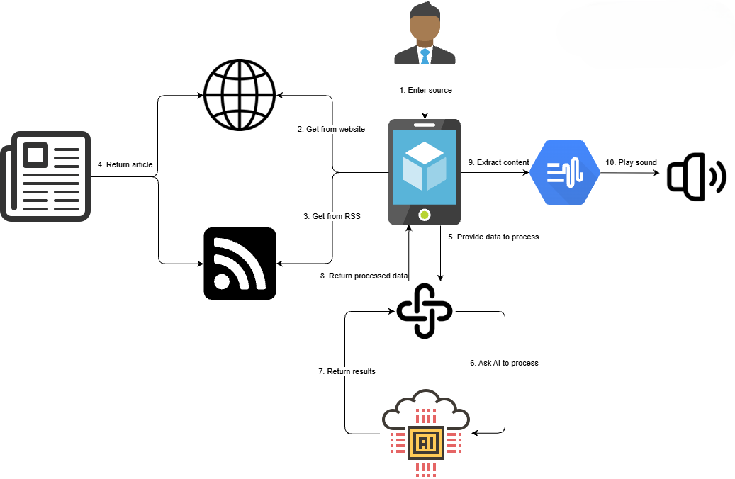
Figure 4-1 Rich Map Diagram

4.3 UML Diagram
When the app is started, it will initiate an app module which consists of all models, data, service and UI classes. The data classes consist of every scheme of data objects, including history, playlist, and they will be used to construct the database table structure. The AppDatabase will be initiated when the app instance is started. The models will be able to directly access the database using the Room persistence library. The other classes will be doing CRUD operations (Create, Read, Update, Delete) using the DAO (Data Access Object) classes to ensure data encapsulation.

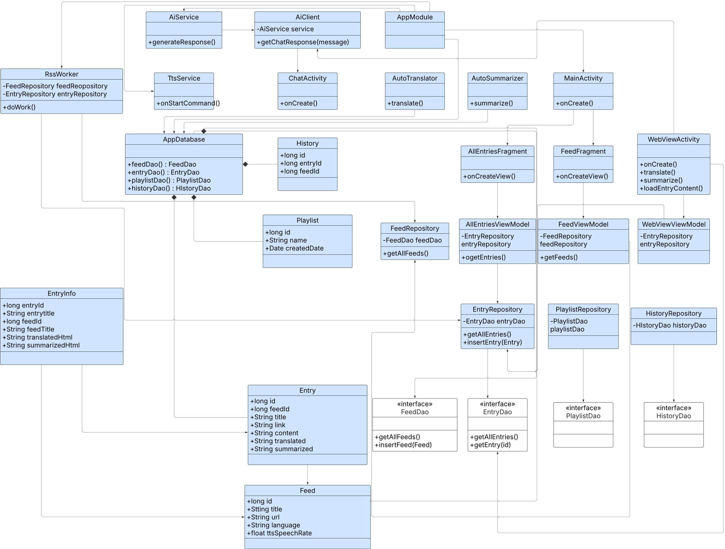
Figure 4-2 UML Class Diagram

4.4 Use Case Diagram
These are the main use cases between user and the application. Cases which involve AI usage such as translation or summarization or chatbot will need to connect to external API for processing.
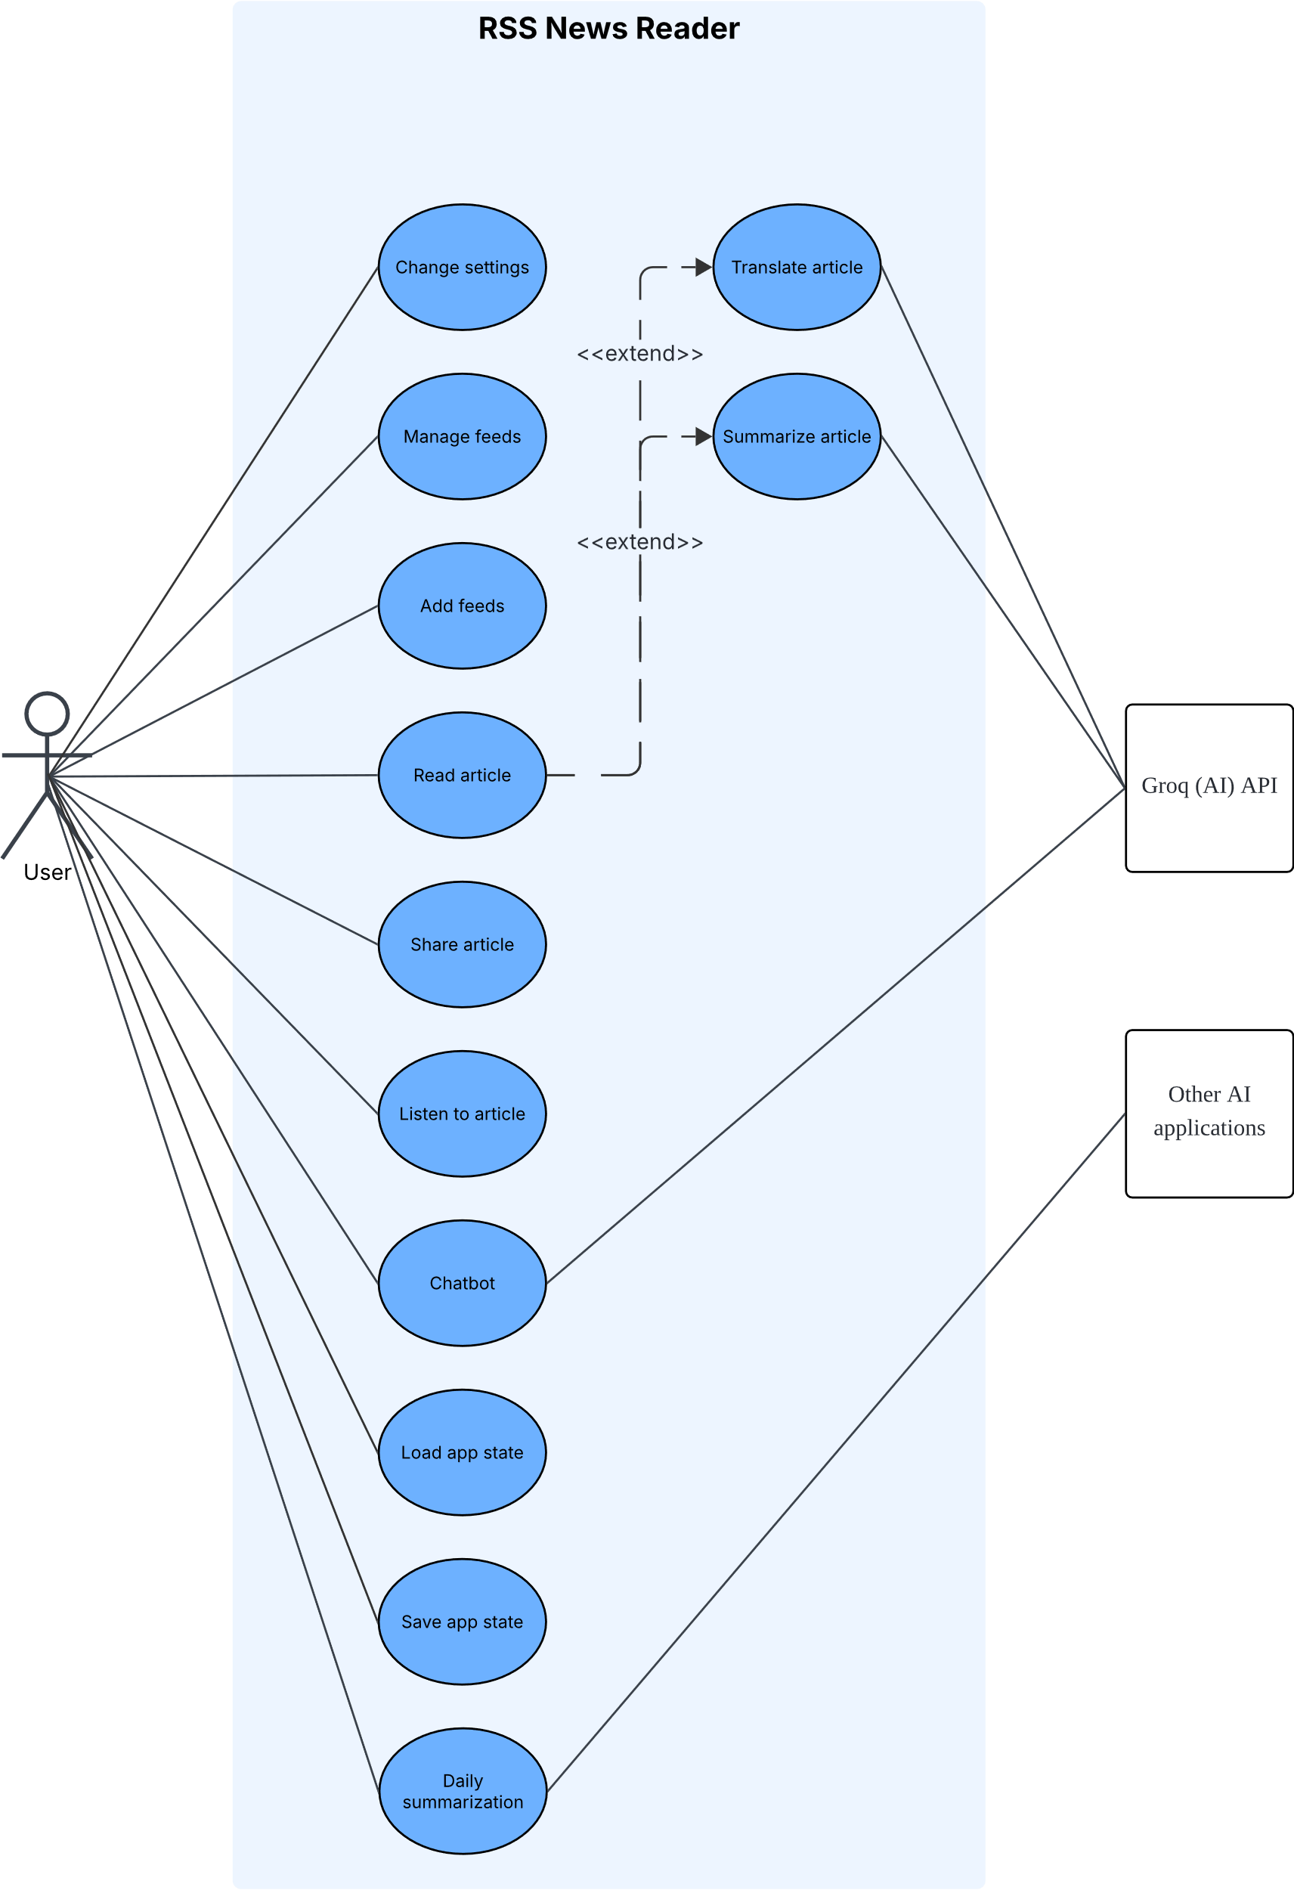
Figure 4-3 Use Case Diagram

4.5 Activity Diagram

4.5.1 Change Settings
Users can manage their customizable settings such as desired language, auto-translation, auto-summarization, summary length, AI model, API key etc. The settings will be saved immediately and actions needed will be taken immediately. These settings will be saved into state xml files when exporting.
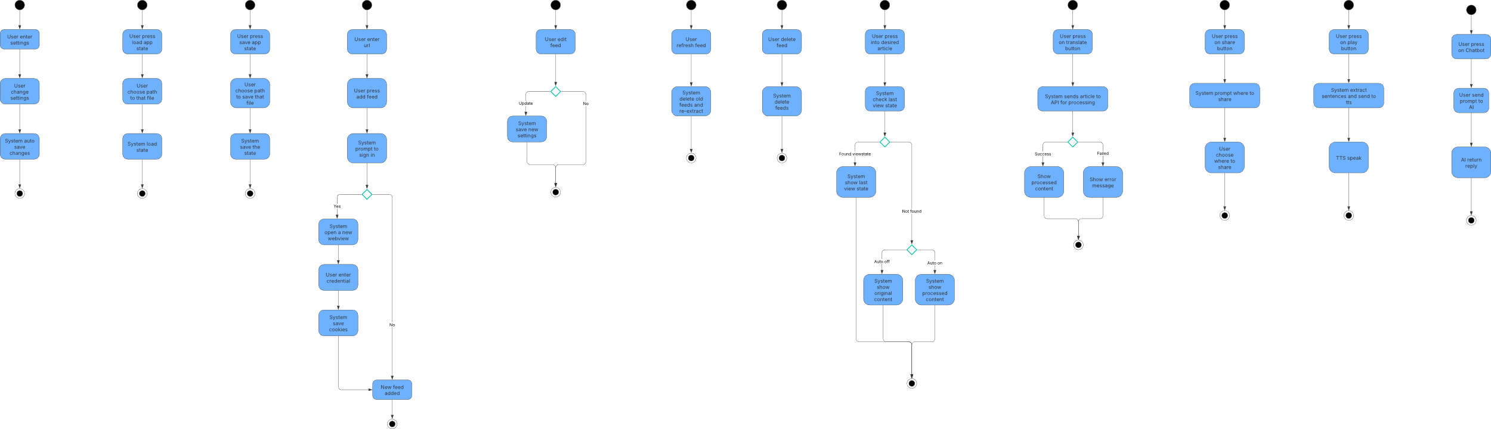
Figure 4-4 Activity Diagram for Settings

4.5.2 Load App State
Users press on load state from the side menu bar. The system will open device default system file manager to allow user to select the xml state file to be loaded.

Figure 4-5 Activity Diagram for Load State

4.5.3 Save App State
Users press on save state from the side menu bar. The system will load current state into an xml file and ask user where to save it.

Figure 4.5.3 Activity Diagram for Save app state

4.5.4 Add New Feeds
Users need to input RSS link or main news page URL and press add feed. System will check for validity of the link and prompt user for logging in. If the user chooses to login, it will open a WebView to allow the user to login to their credentials. Then, the system will save the cookies to automatically login for the same feed in the future.
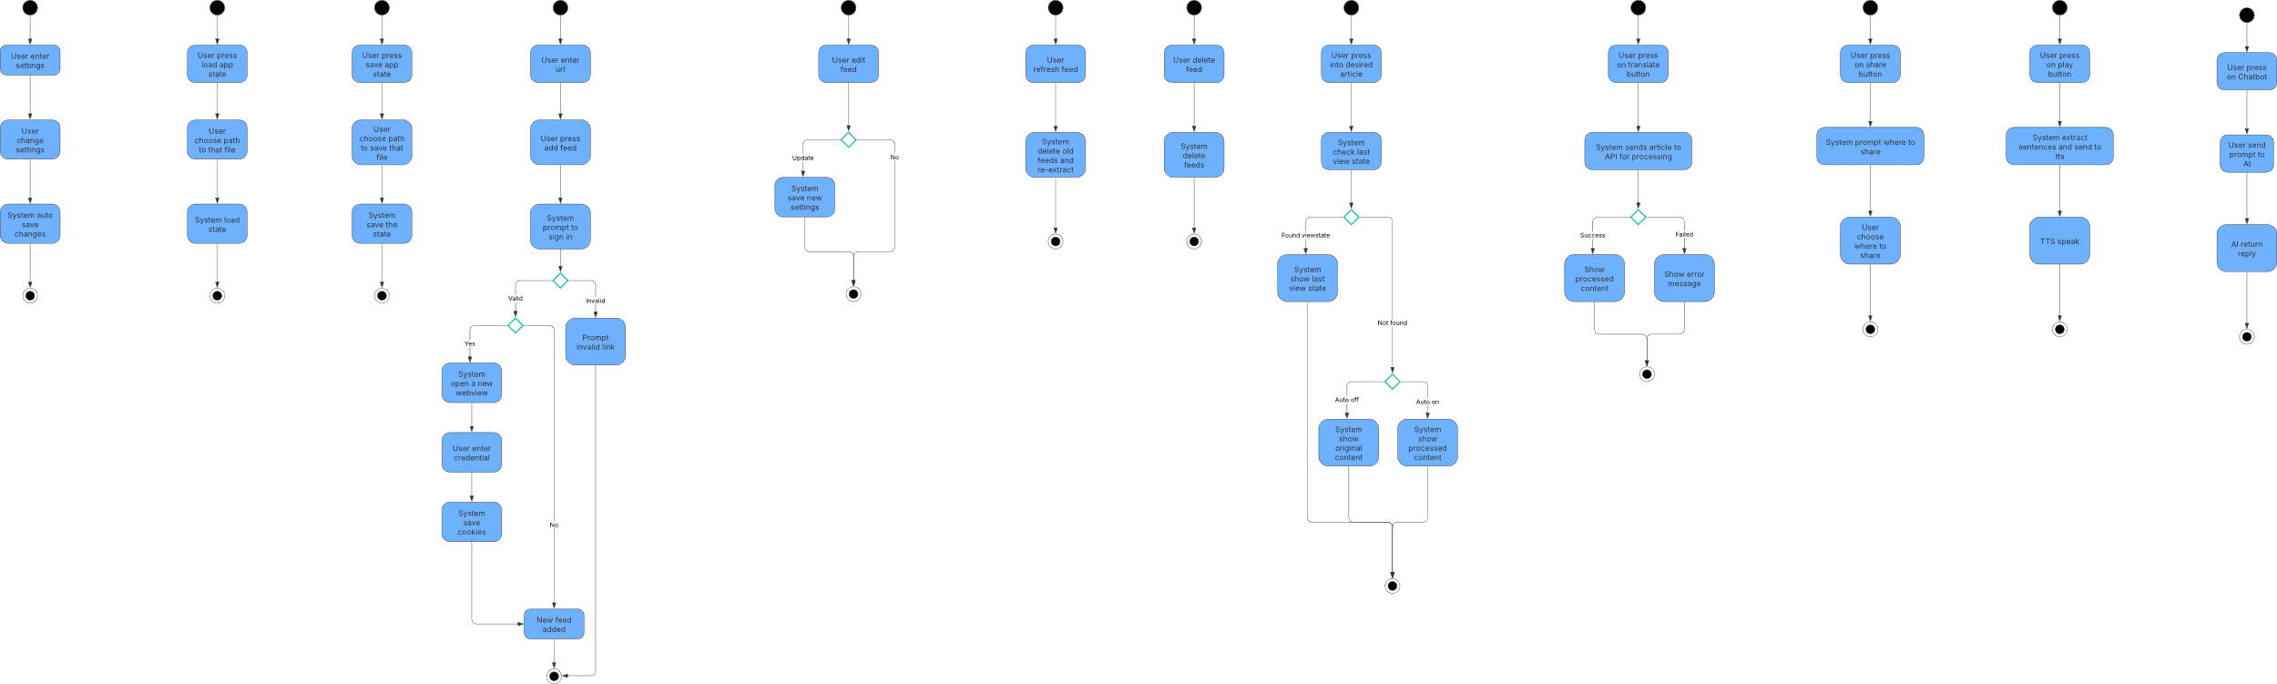
Figure 4-6 Activity Diagram for Add new feed

4.5.5 Edit Feed
Users press the edit button on specific RSS. A popout will be shown with editable values. After editing, pressing “update” will save the new values while pressing cancel will discard the changes.

Figure 4-7 Activity Diagram for Edit feed

4.5.6 Refresh Feed
Users press on refresh feed. The system will delete all the news articles retrieved from that feed and retrieve all again.
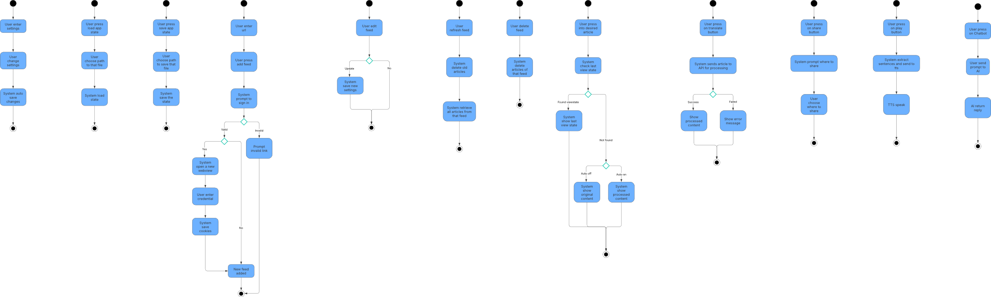
Figure 4-8 Activity Diagram for Refresh feed

4.5.7 Delete Feed
Users press on delete feed. The system will delete all the retrieved news articles.

Figure 4-9 Activity Diagram for Delete feed

4.5.8 View News Article
Users press on desired article to read. The system will load the content using webview accordingly. It will load the view state based on previous view first. If not, it will show summarized content if auto summarization is turned on. Then, followed by translated content if auto translation is turned on. If both are disabled, it will use original extracted content. If the content is not done retrieved, it will use the original unextracted webpage and try to load finish.

Figure 4-10 Activity Diagram for View article

4.5.9 Translate/Summarize News Article
Users press on translate or summarize button. It will only allow the function to be triggered once the content has been successfully extracted. After that, the content will be sent to API to be processed by the AI model. After processing, the API will return the content and the webview will refresh the view to the processed content. If anything goes wrong during the process, such as returned empty content, the system will prompt error message, and user will need to retrigger the function again.
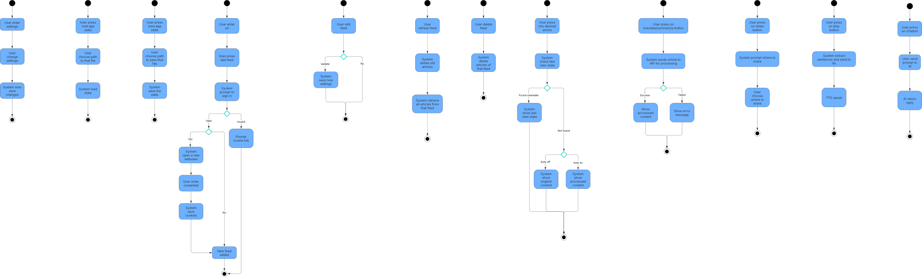
Figure 4-11 Activity Diagram for Translate/Summarize article

4.5.10 Share News Article
Users press on share button. System will prompt users where to share the article. After selecting the sharing method, the URL of the article will be shared then will allow the user to be back on the app.

Figure 4-12 Activity Diagram for Sharing article

4.5.11 Text-to-speech (TTS)
After the article is being extracted, the system will extract the content sentences-by-sentences and queue them for TTS. The TTS will start speaking once the sentences are ready. The state of speaking can be controlled via the buttons in the bottom toolbar.

Figure 4-13 Activity Diagram for Text-to-speech

4.5.12 Chatbot
Users press on chatbot button. Prompt can be input in the bottom textbox and enter will allow the prompt to be sent to AI processing through API. AI will return message once it is done processing the prompt.

Figure 4-14 Activity Diagram for Chatbot

4.5.13 Daily Summarization
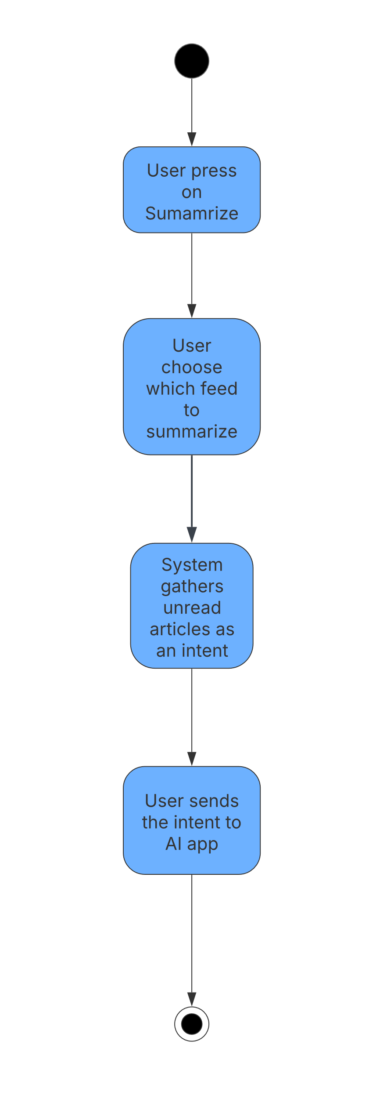
Figure 4-15 Activity Diagram for Daily Summarization

4.6 User Interface Design
The user interface is the main interface between the user and the system for interactions. It plays an important role in user’s experience perspective. These are the screenshots from the current version of the application. More features might be added, and the UI might change in the future.

4.6.1 Main Page
This is the main page of the application. After opening the app, this will be the view of the user to perform the main functionality, which is select a news article and start reading. It also allows users to sort and search for desired news.
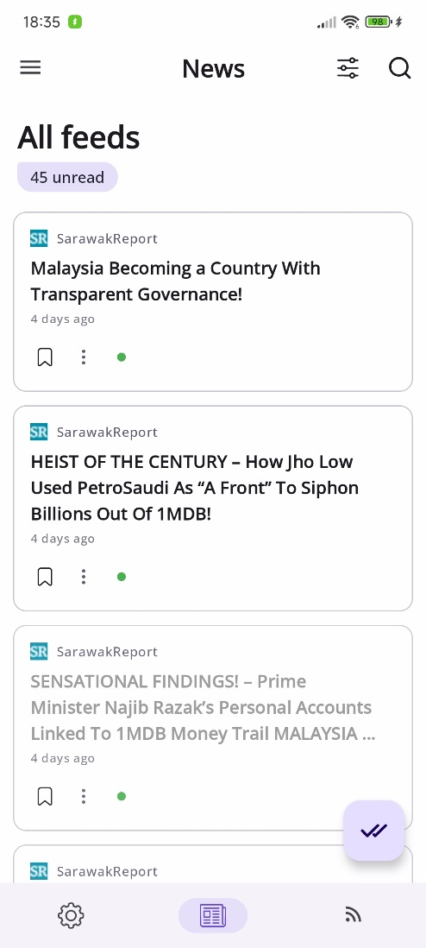
Figure 4-16 Main Page

4.6.2 Non-extracted News Article
This is the news article shown after pressing into a desired title from the main page before done loading or extracting. The indicator of the title will be showing as “red”. It will use the WebView to open the news article (like opening it using browser) before it is fully loaded for extraction. Pressing translate or summarize will prompt the user to wait for extraction, as the TTS function is not ready yet.

Figure 4-17 Non-extracted content

4.6.3 Extracted News Article
This is the news article shown after pressing into a desired title from the main page if it is loaded and extracted. The indicator will be showing green if auto summarization or auto translation is not turned on. It will use the WebView to open the extracted news article in reading mode. Summarization and translation function are available now. Pressing the WebView button will allow switching between original and extracted content.
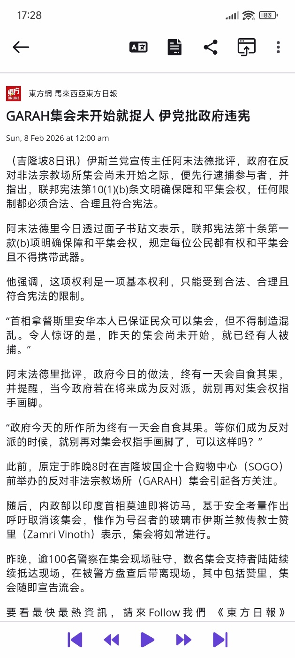
Figure 4-18 Extracted content

4.6.4 Translated News Article
This is the translated news article shown after the content is successfully translated by AI. It will use the WebView to open the translated news article in reading mode. Pressing the toggle translation button can switch between translated and extracted content.
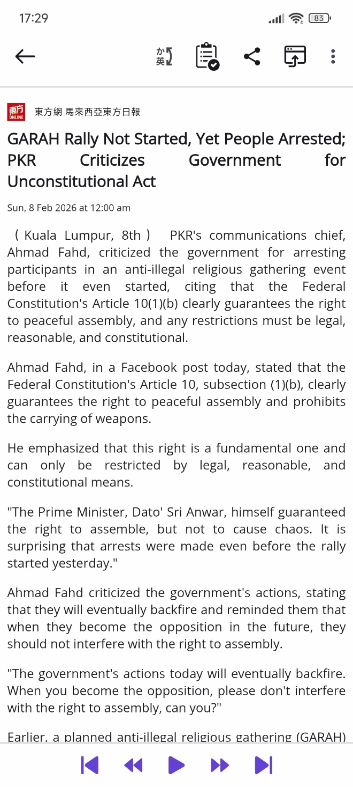
Figure 4-19 Translated content

4.6.5 Summarized News Article
This is the summarized news article shown after the content is successfully summarized by AI. It will use the WebView to open the summarized news article in reading mode. Pressing the toggle summarization button can switch between summarized and extracted content.
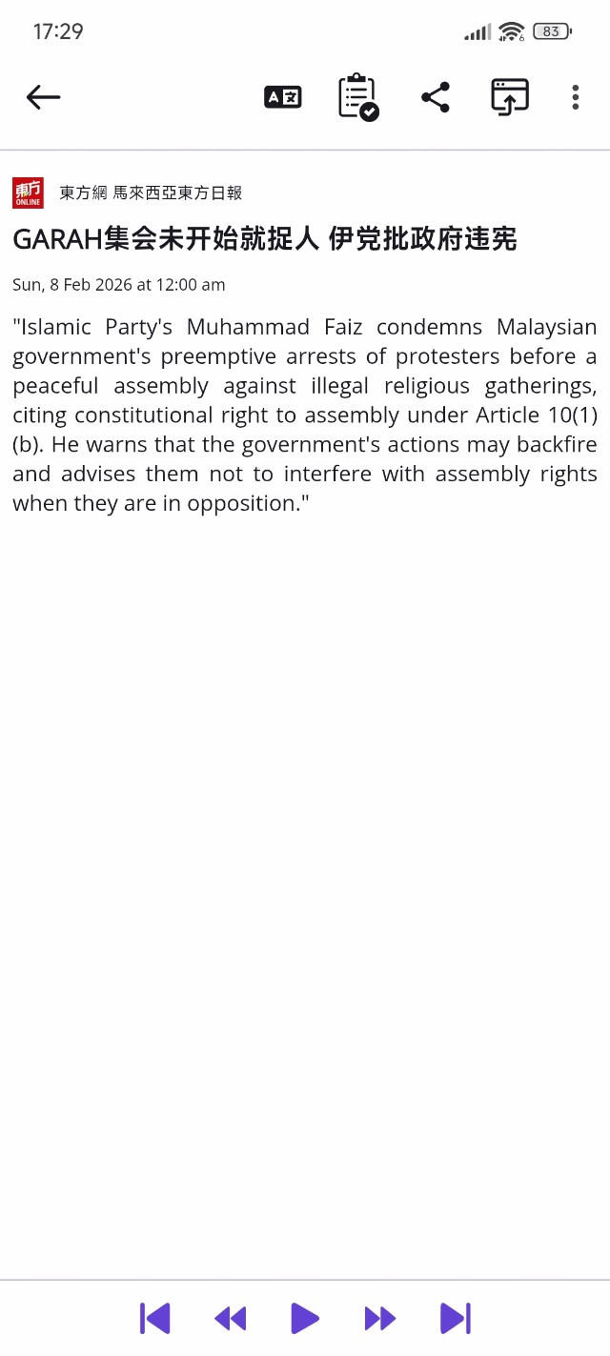
Figure 4-20 Summarized content

4.6.6 Text-to-speech (TTS)
The app will split the extracted content including translated and summarized content sentence by sentence for device default TTS service to read. The sentence highlighted is the sentence that is reading by the TTS. Users can control the playing of the speech by the bottom navigation button.
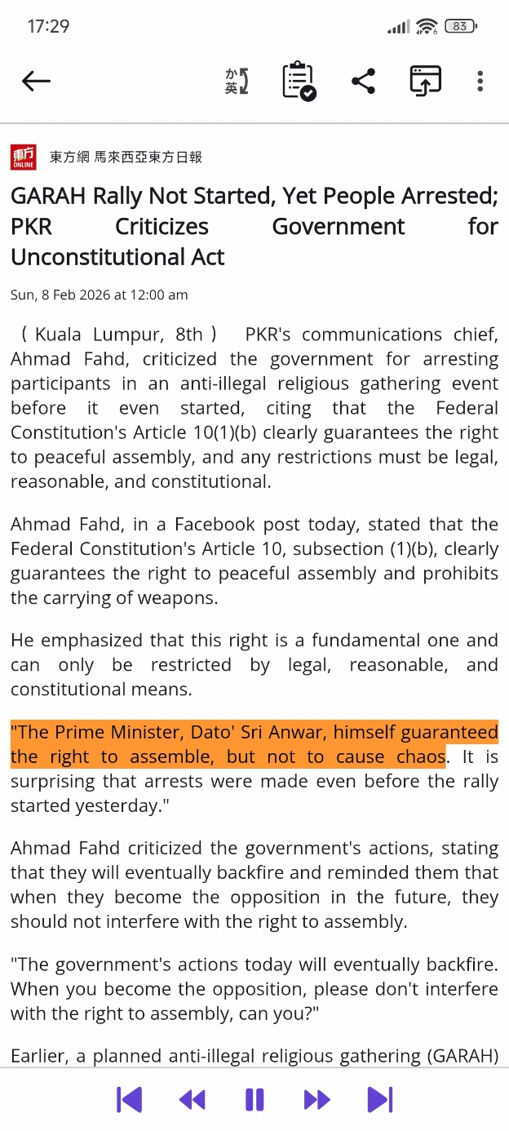
Figure 4-21 TTS

4.6.7 Chatbot
Users can open the chatbot from the hidden menu. It can be used as normal chatbot or can be used to check if the API key is working and get error messages if something went wrong.
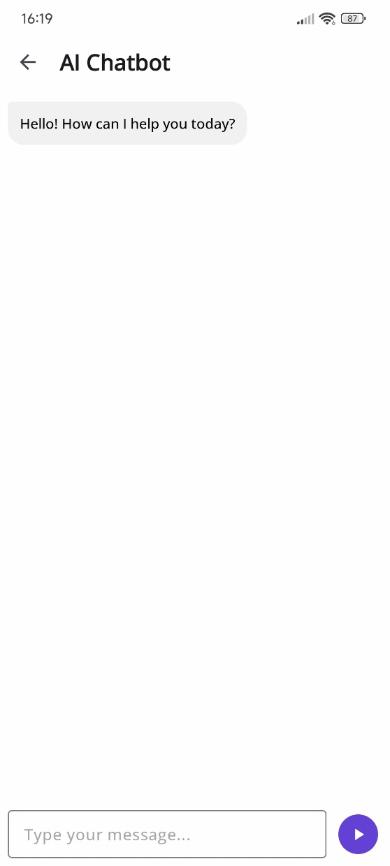
Figure 4-22 Chatbot

4.6.8 Night Mode
The app supports night mode for reducing eyes strain when using the app in dimmed environment.
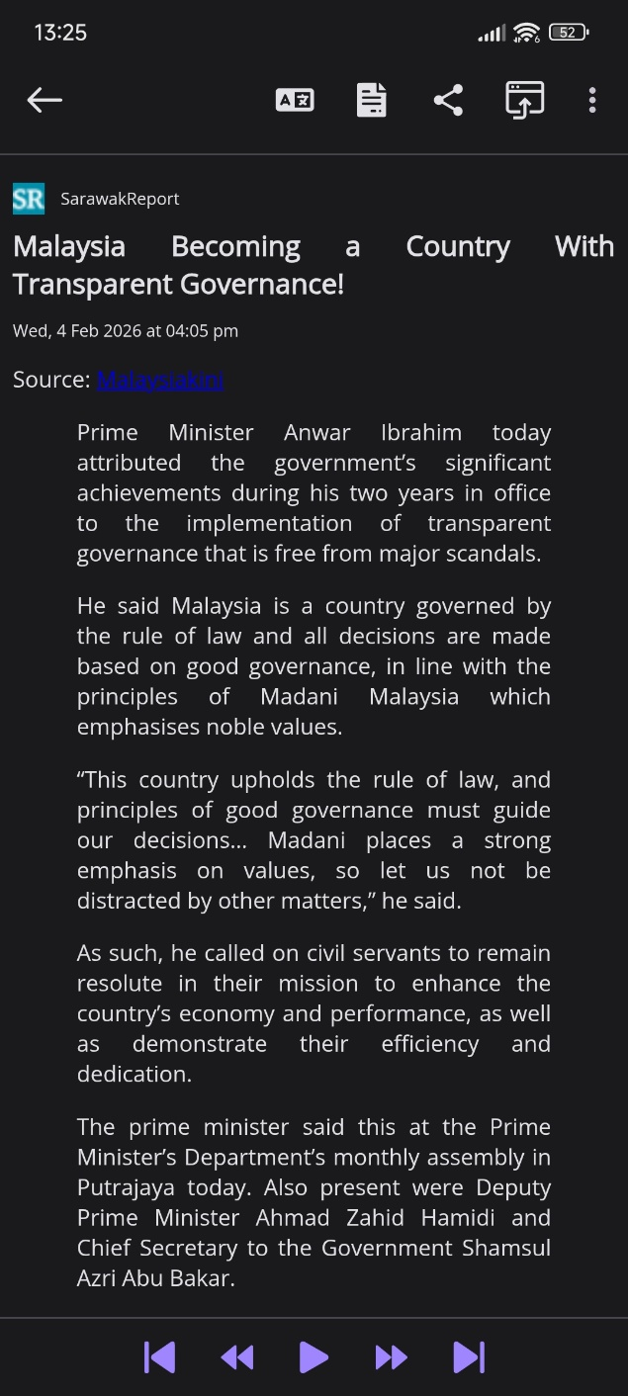
Figure 4-23 Night content
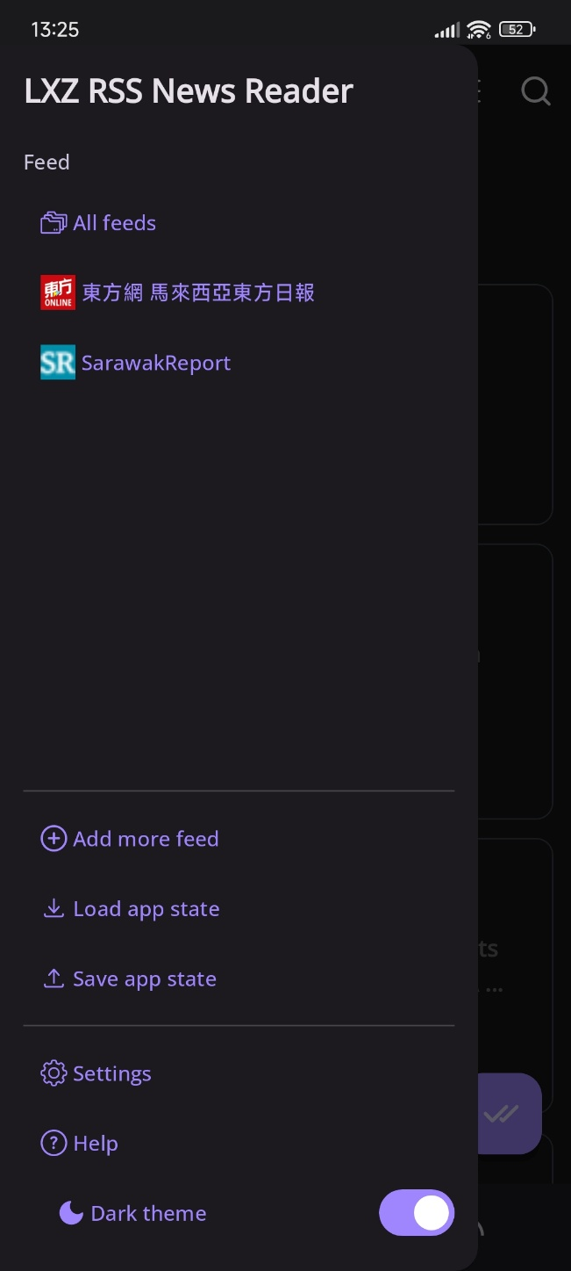
Figure 4-24 Night toolbar

4.6.9 Toolbar
Toolbar allows users to filter between feeds and load / save state.
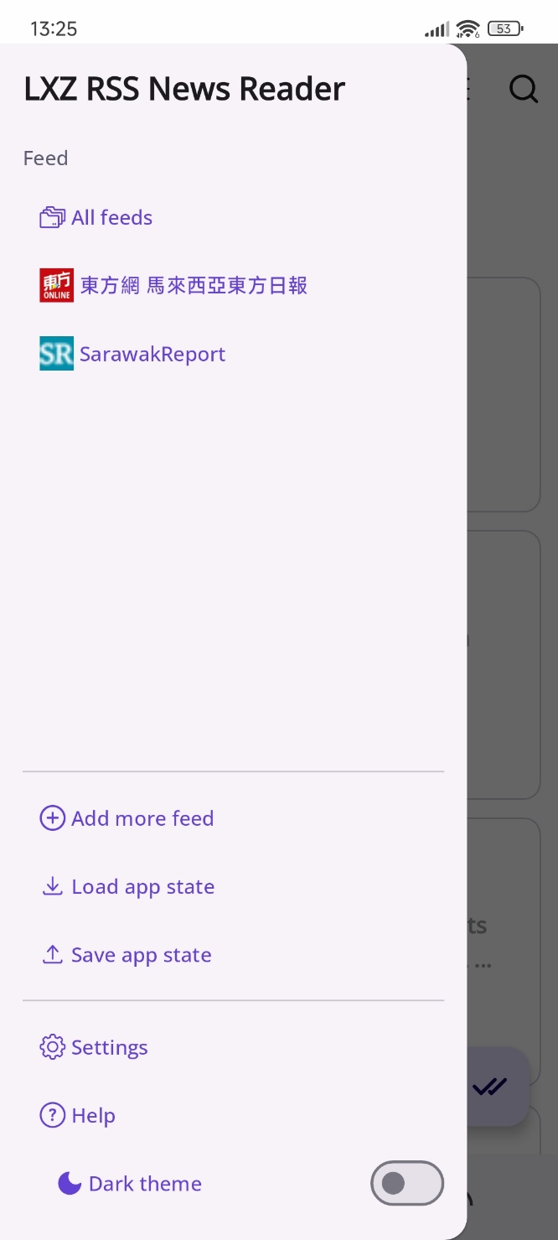
Figure 4-25 Toolbar

4.6.10 Settings
Settings page plays an important role for users to personalize the app to their desired state. More settings allow the app to work closer to user’s own preferences. The settings will be saved and loaded in the state file too.
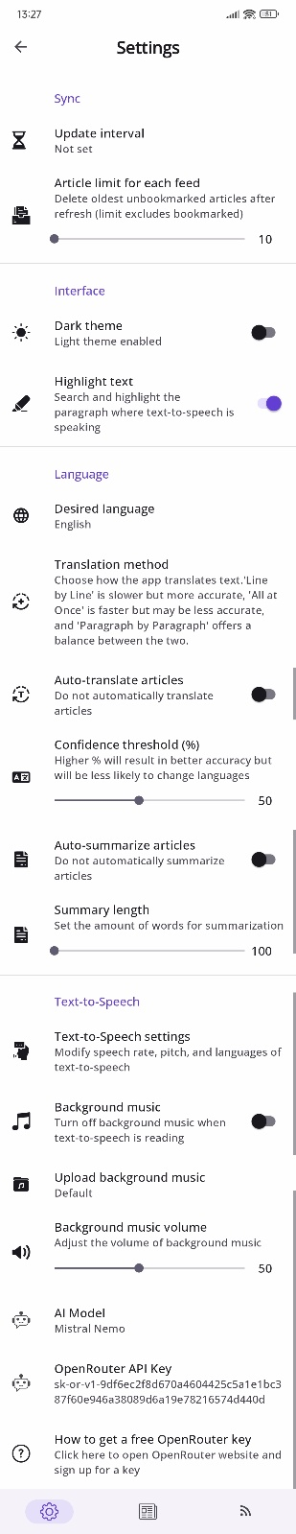
Figure 4-26 Settings

4.6.11 Add New Feeds
Adding new feeds is an important feature in this app. It needs the user to input the RSS link or the URL of the news’ website. After that, it will prompt the user to login to the news or not. If user chooses to login, it will open a WebView for the user to login from the website and save the cookies for that feed to be used in the future.
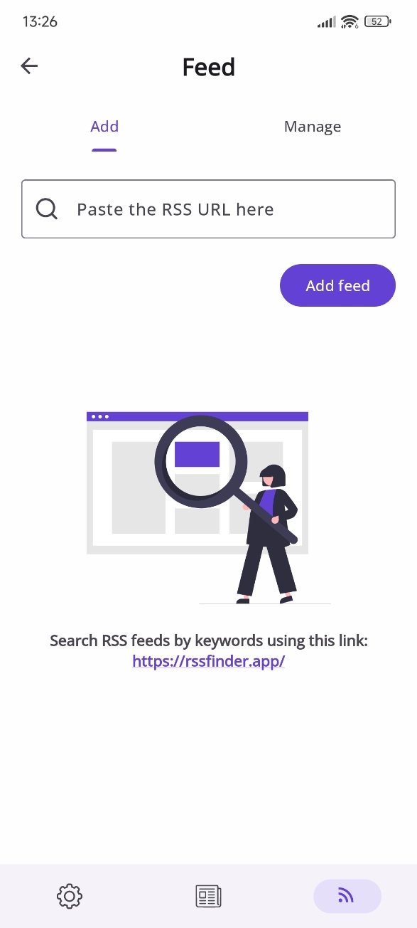
Figure 4-27 Add feeds
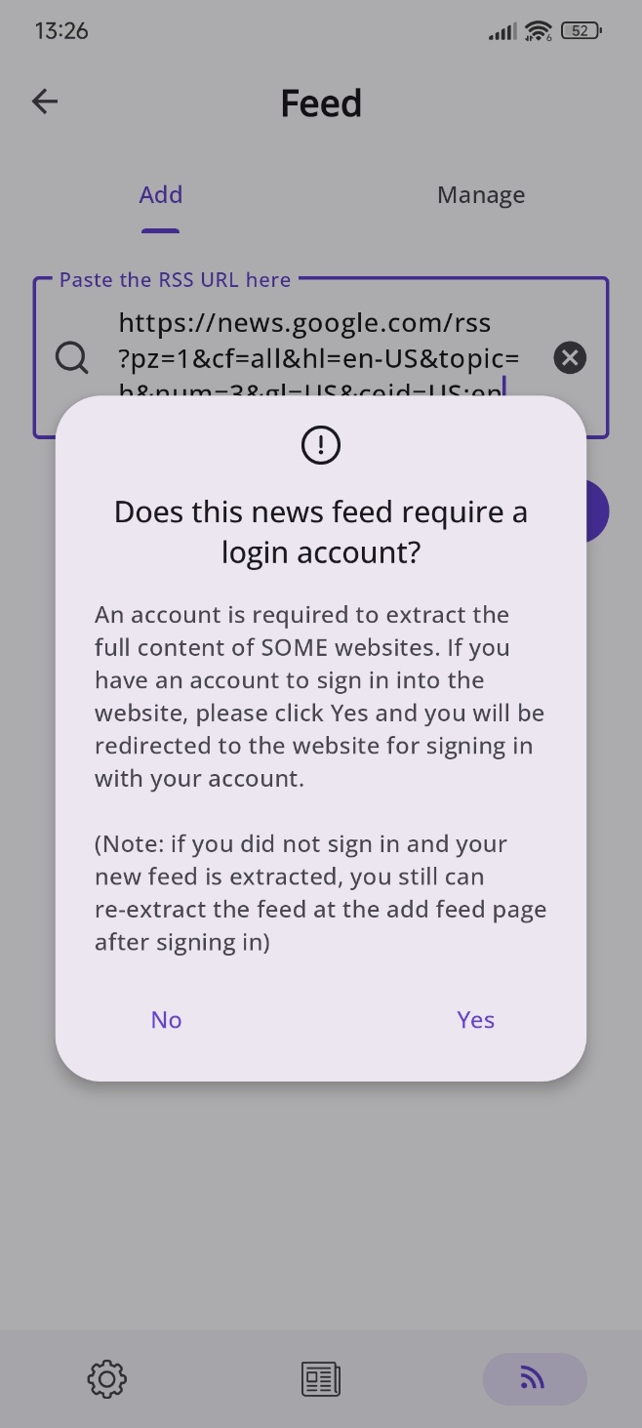
Figure 4-28 Login prompt

4.6.12 Manage Feeds
Managing feeds is important for users to choose the content they want to see. Users can re-extract the feed, which all the articles from that feed will be removed and reloaded. They can also edit the feed and delete the feed. The action will be triggered immediately.
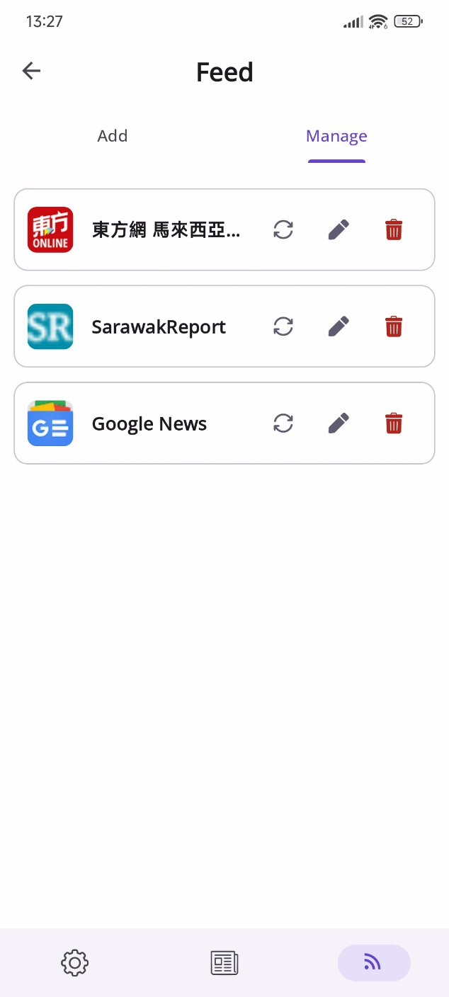
Figure 4-29 Manage feeds

4.6.13 Feed Settings
Users can also change the settings of the feed based on their preferences. Pressing update will immediately apply changes to the feed, while pressing cancel will discard the changes.
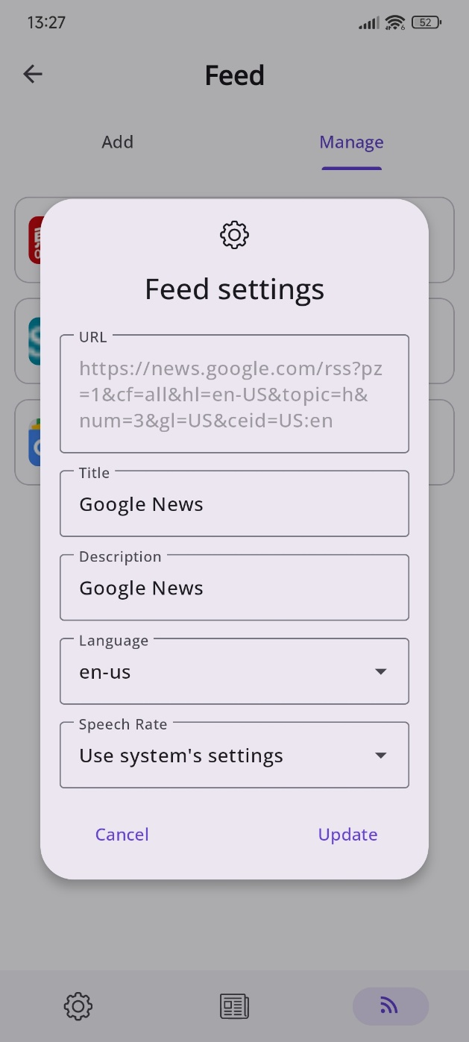
Figure 4-30 Feed settings

4.6.14 Help
Help pages allow users to find solutions for common issues and as a quick start guide to use this app.
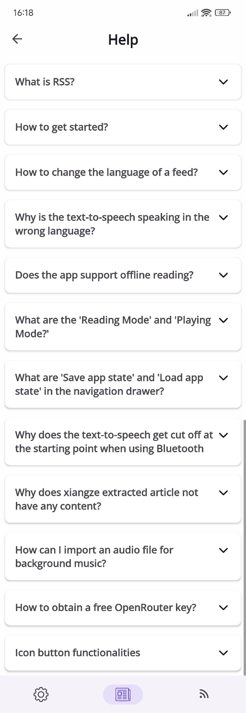
Figure 4-31 Help

4.6.15 Daily Summarization
Daily summarization allows users to summarize the unread articles by using external AI applications in their devices.
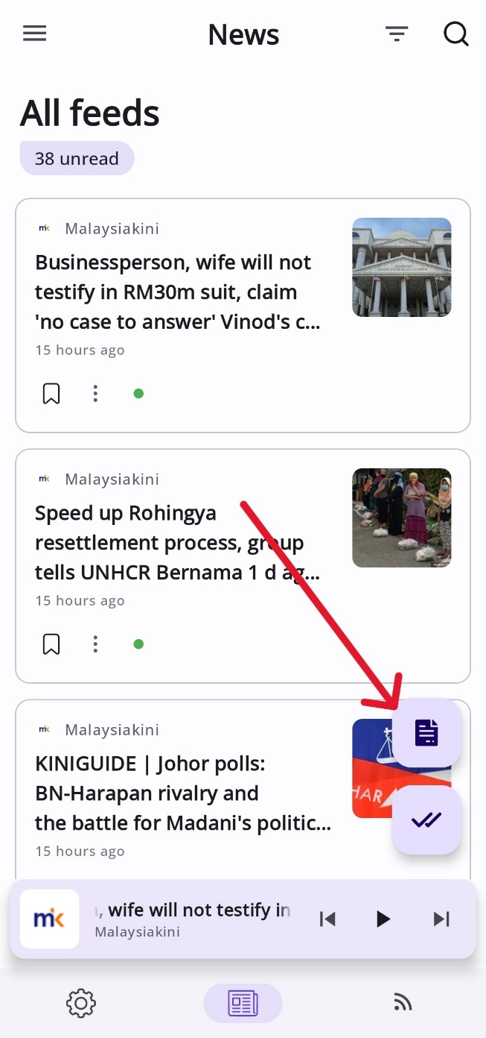

: Implementation Plan

5.1 Gantt Chart
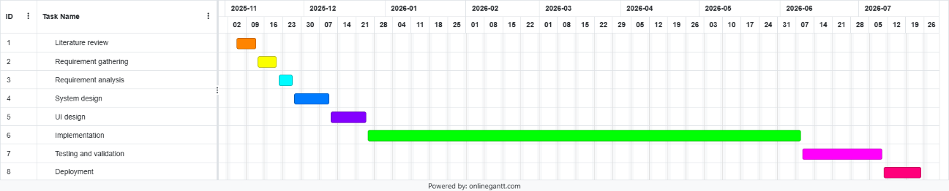
Figure 5-1 Gantt chart

5.2 Overview
The whole process from literature review to deployment of the project will take around 9 months (2 semesters including semester break). Most of the timeline will be used for deployment as this is a complex project that aims to be published in the Play Store for public usage. Therefore, features need to be carefully implemented to avoid uncertainties that might affect user’s experience and ruin the public image of this application. Literature review has been done for basic knowledge to implement an optimal RSS application. After that, requirements for an RSS application expected by the public users are being collected through interview. They are being analyzed and useful recommendations are extracted for implementation. Backend of the system is reviewed and designed first before designing the UI. Then, implementation of the features is being carried out. Lastly, deployment of the final application will be done after the testing and validation for a month.

5.3 Implementation phase
The implementation phase is to implement all the new required functions and fix existing issues in the requirement without breaking the app. It is the most extensive portion of the project which takes roughly 5 months. This phase includes converting the architectural design into a functional Android application. To ensure manageability and modular design, the development will be executed in 4 iterative stages.

5.3.1 Stage 1: Database architecture (1 month)
With new function implemented, structure of database table will need to change. Since this project is forked from previous app, old structure needs to be fully understood before changing anything. After reviewing and understanding the whole structure of the code, new SQL command needs to be added into the code and proper data migration needs to be added to allow users to update to newer version of the app without crashing.

5.3.2 Stage 2: AI integration (2 weeks)
After the database structure is ready for AI integration, new classes will be added into the code to allow the implementation of the AI to handle the API request from both ends. Different AI models will be tested to pick which is the best model to use in different scenarios.

5.3.3 Stage 3: Stabilize existing features (1.5 months)
The app was built with some bugs which will affect user’s experience. Therefore, in this continuation of development, solving every possible bug is also one of the important tasks for stable deployment of the app.

5.3.4 Stage 4: Implement new features (2 months)
New features will be implemented into this app while ensuring the working state of the old functions.

5.4 Testing phase
The testing phase is critical to ensure the reliability and stability of the application across the targeted Android versions (Android 10 to 17). Testing will be conducted systematically to validate both the inherited codebase and the newly implemented AI modules.

5.4.1 Unit Testing
Unit testing focuses on validating individual components of the application in isolation to ensure each function performs as intended.
- Logic Verification: Testing the AutoSummarizer and AutoTranslator classes to ensure they correctly format API requests before transmission.
- Data Models: Validating the Entry and Feed data objects to ensure proper serialization and deserialization within the Room database.
- Utility Functions: Testing string manipulation logic used for content sanitization to ensure "Read More" links and social media widgets are accurately identified for removal.

5.4.2 Integration Testing
Integration testing assesses the interaction between different modules and external services to identify communication errors.
- API Connectivity: Verifying the seamless exchange of data between the application and the Groq API for translation and summarization tasks.
- Database Integration: Testing the interaction between the FeedViewModel and the FeedRepository to ensure news articles are correctly cached for offline reading.
- Audio Focus: Specifically testing the TtsService to ensure audio playback resumes correctly after interruptions from external apps like Spotify or system notifications.

5.4.3 System Testing
System testing evaluates the application as a complete, integrated system to ensure it meets all functional and non-functional requirements.
- WebView Stability: Validating the rendering of JavaScript-heavy sites (e.g., Harian Metro) to ensure the extraction module functions without crashing the app.
- Hardware Compatibility: Testing the application on various device types, focusing on the pinch-to-zoom accessibility feature and Bluetooth media button controls.
- Performance Monitoring: Measuring startup times and feed update latency to ensure responsiveness meets general system standards.

5.4.4 User Acceptance Testing (UAT)
UAT is the final validation stage where the application is tested by potential users to ensure it meets their practical needs and expectations.
- Beta Testing: Re-engaging the initial interview candidates to verify that their identified "pain points" such as translation context and TTS continuity have been effectively resolved.
- Usability Feedback: Evaluating the intuitiveness of the "View Toggling" feature between summarized and full content to ensure a "calm" reading environment.
- Accessibility Check: Confirming that the application is suitable for both casual and power users, specifically regarding the ease of obtaining and entering Groq API keys.

5.5 Deployment phase
The deployment phase marks the transition of the application from a development environment to the public domain. Given the project's goal to reach a global audience via the Play Store. Therefore, this phase involves several critical steps to ensure the application is production ready.

5.5.1 Application Hardening and Optimization
Utilizing ProGuard or R8 to shrink, optimize and obfuscate the codebase to ensure the security of the modular architecture and protecting intellectual property.
Ensuring that all sensitive data, such as default API keys or internal endpoints, are moved to secure storage or externalized to prevent unauthorized access.
Finalizing the "cleaning" of distracting content like advertisements to ensure the application remains resource-efficient during live execution.

5.5.2 Play Store Submission Preparation
Confirming the application successfully targets the required range of Android 10 (API level 29) to Android 17, as defined in the project scope.
Preparing the necessary metadata, including high-resolution screenshots of the "Main Page", "Reading Mode" and "AI Chatbot" interfaces to demonstrate the app's features to potential users.
Drafting a clear privacy policy that explains how the application handles user-provided Groq API keys and the absence of profit-driven algorithmic tracking.

5.3.3 Launch and Post-Deployment Monitoring
Executing a staged rollout starting with a closed beta group to monitor for any "instability and bugs" that might have been missed during the internal testing phase.
Officially publishing the APK/App Bundle to the Google Play Store for public consumption.
Establishing a system for users to report errors such as JavaScript-heavy sites failing to render to be addressed in subsequent maintenance updates.

: Conclusion

The development of the AI-Powered Smart RSS News Reader addresses critical technical and psychological gaps in the current digital news landscape. By evolving the traditional RSS "pull" model into an intelligent, adaptive system, this project provides a "calm" reading environment that prioritizes user agency over profit-driven algorithmic curation.

The integration of Large Language Models (LLMs) via Groq successfully overcomes the limitations of word-for-word translation. It can provide contextually accurate content that preserves cultural nuances. Furthermore, features such as AI-driven summarization, content sanitization and seamless TTS continuity directly address the pain points of information overload and fragmented consumption identified during user interviews.

Key milestones achieved during this interim phase include validation of functional requirements through targeted interviews with diverse user personas, establishing a robust MVVM architecture and Room database structure to ensure high performance and offline reliability and designing a web scraping module to maintain content accessibility as traditional news portals move away from native RSS feeds.

As the project moves into the full implementation and deployment phases, the focus will shift toward stabilizing the codebase and optimizing AI latency to ensure a seamless user experience. Ultimately, this application aims to empower users worldwide with a private, streamlined and resource-efficient gateway to global information.

Reference
Ananthanarayanan, G., Blagsvedt, S., Toyama, K., & Com, K. (n.d.). OWeB: A Framework for Offline Web Browsing. Retrieved February 9, 2026, from https://www.microsoft.com/en-us/research/wp-content/uploads/2016/02/OWeB-LAWeb2006.pdf
Blekas, A., Garofalakis, J., & Stefanis, V. (n.d.). Use of RSS feeds for Content Adaptation in Mobile Web Browsing. Retrieved February 9, 2026, from https://www.ambuehler.ethz.ch/cdstore/www2006-wwa/p79-blekas.pdf
Brumby, D. P., Salvucci, D. D., & Howes, A. (2009). Focus on driving. Proceedings of the SIGCHI Conference on Human Factors in Computing Systems. https://doi.org/10.1145/1518701.1518950
De, D., El Jamal, M., Aydemir, E., & Khera, A. (2025). Social Media Algorithms and Teen Addiction: Neurophysiological Impact and Ethical Considerations. Cureus, 17(1), 1–7. https://doi.org/10.7759/cureus.77145
Hu, S.-C. ., & Chen, I.-C. . (2011). Alleviating information overload caused by volumes of numerical web data: the concept and development process. IET Software, 5(5), 445. https://doi.org/10.1049/iet-sen.2010.0099
Huang, Y., & Liu, W. (2024). Evaluating the Translation Performance of Large Language Models Based on Euas-20. ArXiv.org. https://arxiv.org/abs/2408.03119
MA, Dan. Push or Pull? A Website's Strategic Choice of Content Delivery Mechanism. (2015). Journal of Management Information Systems. 32, (1), 291-321. https://ink.library.smu.edu.sg/sis_research/2441
Milli, S., Carroll, M., Wang, Y., Pandey, S., Zhao, S., & Dragan, A. D. (2023, November 8). Engagement, User Satisfaction, and the Amplification of Divisive Content on Social Media. ArXiv.org. https://doi.org/10.48550/arXiv.2305.16941
Pace, S. (2004). A grounded theory of the flow experiences of Web users. International Journal of Human-Computer Studies, 60(3), 327–363. https://doi.org/10.1016/j.ijhcs.2003.08.005
Wallaroo Media. (2024, May 7). TikTok Statistics – Everything You Need to Know [May 2024 Update]. Wallaroo Media. https://wallaroomedia.com/blog/tiktok-statistics/
‌

Appendix A


Gantt Chart

Appendix B
Meeting logs 1-6

CPT6324 Project (FYP1) Meeting Log
Trimester: November 2025 (Trimester ID:2530)

Meeting Date:  5/11/2025 | Meeting No.:  1
Meeting Mode:
In person
Project ID:  73 | Project Type:  Application-based
Project Title :
AI-Powered Smart RSS News Reader with Translation, Summarization, and Enhanced Web Handling
Student ID :  1211106818 | Student Name:  Lee Xiang Ze
Student Programme and Specialisation:
Bachelors in Computer Science with a Specialisation in Software Engineering
Supervisor Name:  Dr. Ian Chai | Co-Supervisor Name:  (if applicable)
Collaborating Company:  (if applicable) | Company Supervisor Name:  (if applicable)

1. WORK DONE

Tasks: Implementation

Details (in point form):
- Getting familiar with android studio and android app development using java.
- Create new GitHub repository and fork existing code (https://github.com/TheINSANE333/RSSNewsReader2025).
- Clone existing code and understand it.
- Trying out with the existing application.
- Implemented pinch-to-zoom feature (Requirement 1.1).

2. WORK TO BE DONE

Tasks: Implementation / Testing

Details (in point form):
- Study how to implement DeepSeek AI.
- Try out DeepSeek AI implementation.

3. PROBLEMS ENCOUNTERED AND SOLUTIONS
- Lack of documentation of existing code make the code very hard to understand.
- First time developing android app.
- Use Internet to find solutions. (https://stackoverflow.com/questions/7121053/how-to-enable-zoom-controls-and-pinch-zoom-in-a-webview)

4. COMMENTS (Supervisor / Co-Supervisor / Company Supervisor)

Good progress for the first week. Please continue.




…………………………… …………………………...
Supervisor’s Signature STUDENT’S SIGNATURE

…………………………….. ………………………………….
Co-Supervisor’s Signature Company Supervisor’s Signature
(if applicable) (if applicable)

CPT6324 Project (FYP1) Meeting Log
Trimester: November 2025 (Trimester ID:2530)

Meeting Date:  12/11/2025 | Meeting No.:  2
Meeting Mode:
In person
Project ID:  73 | Project Type:  Application-based
Project Title :
AI-Powered Smart RSS News Reader with Translation, Summarization, and Enhanced Web Handling
Student ID :  1211106818 | Student Name:  Lee Xiang Ze
Student Programme and Specialisation:
Bachelors in Computer Science with a Specialisation in Software Engineering
Supervisor Name:  Dr. Ian Chai | Co-Supervisor Name:  (if applicable)
Collaborating Company:  (if applicable) | Company Supervisor Name:  (if applicable)

1. WORK DONE

Tasks: Implementation

Details (in point form):
- Implemented DeepSeek AI using API (openRouter) into the software.
- Create a chatbot page for testing.
2. WORK TO BE DONE

Tasks: Implementation / Testing

Details (in point form):
- Figure out how to import content into the AI.
- Figure out how to export translated content into the page.
3. PROBLEMS ENCOUNTERED AND SOLUTIONS
- First time implementing AI.
- Use Internet resources. (https://openrouter.ai/docs/quickstart)
4. COMMENTS (Supervisor / Co-Supervisor / Company Supervisor)

Start trying to ask Deepseek to do stuff with the article, e.g. translate, and remove extra stuff.




…………………………… …………………………...
Supervisor’s Signature STUDENT’S SIGNATURE

…………………………….. ………………………………….
Co-Supervisor’s Signature Company Supervisor’s Signature
(if applicable) (if applicable)
CPT6324 Project (FYP1) Meeting Log
Trimester: November 2025 (Trimester ID:2530)

Meeting Date:  19/11/2025 | Meeting No.:  3
Meeting Mode:
In person
Project ID:  73 | Project Type:  Application-based
Project Title :
AI-Powered Smart RSS News Reader with Translation, Summarization, and Enhanced Web Handling
Student ID :  1211106818 | Student Name:  Lee Xiang Ze
Student Programme and Specialisation:
Bachelors in Computer Science with a Specialisation in Software Engineering
Supervisor Name:  Dr. Ian Chai | Co-Supervisor Name:  (if applicable)
Collaborating Company:  (if applicable) | Company Supervisor Name:  (if applicable)

1. WORK DONE

Tasks: Implementation

Details (in point form):
- Changed the DeepSeek AI model into OpenAI: gpt-oss-20b
- Successfully translated the page while retaining the HTML format
- Created alpha release with APK in GitHub (Release Initial AI Release (v0.0.1-alpha) · TheINSANE333/RSSNewsReader2025)
2. WORK TO BE DONE

Tasks: Implementation / Testing

Details (in point form):
- Since the translation using AI can retain HTML format, we can remove the restriction on translating the page in reading mode only.
- Change everything from DeepSeek AI model to OpenAI as it is more reliable after comparing.
3. PROBLEMS ENCOUNTERED AND SOLUTIONS
- The DeepSeek API encountering various errors when translating the page.
- Switch to OpenAI model to solve these errors.
- API key is exposed to public which is not safe.
4. COMMENTS (Supervisor / Co-Supervisor / Company Supervisor)

I couldn’t test your app because of the signature clash with the senior’s app, but now after you change the signature, can give me a version to try.
Look for ways to split when the article is long and exceeds the limit.




…………………………… …………………………...
Supervisor’s Signature STUDENT’S SIGNATURE

…………………………….. ………………………………….
Co-Supervisor’s Signature Company Supervisor’s Signature
(if applicable) (if applicable)

CPT6324 Project (FYP1) Meeting Log
Trimester: November 2025 (Trimester ID:2530)

Meeting Date:  26/11/2025 | Meeting No.:  4
Meeting Mode:
In person
Project ID:  73 | Project Type:  Application-based
Project Title :
AI-Powered Smart RSS News Reader with Translation, Summarization, and Enhanced Web Handling
Student ID :  1211106818 | Student Name:  Lee Xiang Ze
Student Programme and Specialisation:
Bachelors in Computer Science with a Specialisation in Software Engineering
Supervisor Name:  Dr. Ian Chai | Co-Supervisor Name:  (if applicable)
Collaborating Company:  (if applicable) | Company Supervisor Name:  (if applicable)

1. WORK DONE

Tasks: Implementation

Details (in point form):
- Refactor some naming in packages
- Successfully split long content into multiple chunks to avoid hitting token limit
- Updated APK in GitHub (Release Bug Fix Update – Chunking & Package Refactor (v0.0.2-alpha) · TheINSANE333/RSSNewsReader2025)
2. WORK TO BE DONE

Tasks: Implementation / Testing

Details (in point form):
- Since the translation using AI can retain HTML format, we can remove the restriction on translating the page in reading mode only.
3. PROBLEMS ENCOUNTERED AND SOLUTIONS
- Longer translation time needed as it has been splitted in multiple requests
4. COMMENTS (Supervisor / Co-Supervisor / Company Supervisor)

The TTS should check to see if the article has been translated. If no, read in the original language. If yes, then read in the result language.




…………………………… …………………………...
Supervisor’s Signature STUDENT’S SIGNATURE

…………………………….. ………………………………….
Co-Supervisor’s Signature Company Supervisor’s Signature
(if applicable) (if applicable)

CPT6324 Project (FYP1) Meeting Log
Trimester: November 2025 (Trimester ID:2530)

Meeting Date:  3/12/2025 | Meeting No.:  5
Meeting Mode:
In person
Project ID:  73 | Project Type:  Application-based
Project Title :
AI-Powered Smart RSS News Reader with Translation, Summarization, and Enhanced Web Handling
Student ID :  1211106818 | Student Name:  Lee Xiang Ze
Student Programme and Specialisation:
Bachelors in Computer Science with a Specialisation in Software Engineering
Supervisor Name:  Dr. Ian Chai | Co-Supervisor Name:  (if applicable)
Collaborating Company:  (if applicable) | Company Supervisor Name:  (if applicable)

1. WORK DONE

Tasks: Implementation

Details (in point form):
- Redo auto translation function using AI (not fully tested)
2. WORK TO BE DONE

Tasks: Implementation / Testing

Details (in point form):
- Find ways to overcome API limitations
3. PROBLEMS ENCOUNTERED AND SOLUTIONS
- LLM API provider is returning error 429 (exceed limitation)
- Need to wait until next year
4. COMMENTS (Supervisor / Co-Supervisor / Company Supervisor)

Investigate injecting into a web page and avoid the API limit that way.




…………………………… …………………………...
Supervisor’s Signature STUDENT’S SIGNATURE

…………………………….. ………………………………….
Co-Supervisor’s Signature Company Supervisor’s Signature
(if applicable) (if applicable)

CPT6324 Project (FYP1) Meeting Log
Trimester: November 2025 (Trimester ID:2530)

Meeting Date:  10/12/2025 | Meeting No.:  6
Meeting Mode:
In person
Project ID:  73 | Project Type:  Application-based
Project Title :
AI-Powered Smart RSS News Reader with Translation, Summarization, and Enhanced Web Handling
Student ID :  1211106818 | Student Name:  Lee Xiang Ze
Student Programme and Specialisation:
Bachelors in Computer Science with a Specialisation in Software Engineering
Supervisor Name:  Dr. Ian Chai | Co-Supervisor Name:  (if applicable)
Collaborating Company:  (if applicable) | Company Supervisor Name:  (if applicable)

1. WORK DONE

Tasks: Implementation

Details (in point form):
- Redo auto translation function using AI
- Rewrite the logics and flow for auto translation
- The auto translation will now be triggered one by one
- Any errors will immediately stop the translation to avoid token wastage
- New release in GitHub (Release AI-Powered Auto Translation & Rate-Limit Safe Pipeline (v0.0.3-alpha) · TheINSANE333/RSSNewsReader2025)
2. WORK TO BE DONE

Tasks: Implementation / Testing

Details (in point form):
- Find ways to overcome API limitations
- Fix the title translation issue
3. PROBLEMS ENCOUNTERED AND SOLUTIONS
- LLM API provider is returning error 429 (exceed limitation)
- Native translation will translate everything in once
- Native translation has a bug that will retranslate translated articles
- Redo the auto translation function
4. COMMENTS (Supervisor / Co-Supervisor / Company Supervisor)

Load app state seems to be broken now. I shared the app state file with you so that you can test it.




…………………………… …………………………...
Supervisor’s Signature STUDENT’S SIGNATURE

…………………………….. ………………………………….
Co-Supervisor’s Signature Company Supervisor’s Signature
(if applicable) (if applicable)

Appendix C
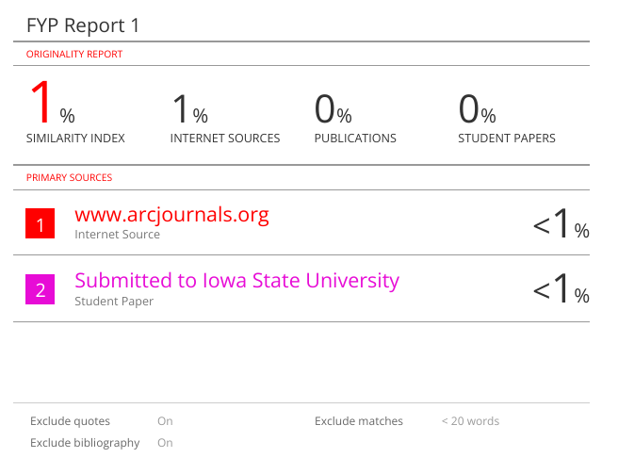

Appendix D
Interview Set #1
Target: Assoc. Prof. Dr. Chai Ian
Goal #1: To validate the need for context-aware LLM translation and content cleaning.
- How many different news sources or blogs do you typically monitor daily to stay informed on international topics?
- When using standard translation tools, how often do you find that local idioms or specific cultural names are translated incorrectly as literal terms?
- Does the presence of "Read More" prompts, paywalls, or embedded social media widgets significantly degrade your concentration while reading long articles?
- Would a feature that automatically translates both the title and body text using a Large Language Model (LLM) provide enough value to justify using a personal API key?
- How important is it for the "sanitized" version of an article to maintain the original formatting and tone?

Goal #2: To validate the importance of TTS continuity and focus management.
- What is your primary method of consuming news during your commute (e.g., reading on screen or using Text-to-Speech)?
- How often does your current TTS reader lose its place or fail to resume after your screen rotates or you receive a notification?
- When using a Bluetooth headset, do you find the inability to use hardware "Play/Pause" buttons a significant barrier to usability?
- Would a feature that summarizes a 2000-word article into a 100-word brief save you significant time during your daily routine?
- If the app could play background music while the TTS is reading, would that enhance your "eyes-free" news experience?

Goal #3: To validate custom web scraping and offline browsing modules.
- How many of the niche blogs or local portals you follow currently lack a native RSS feed?
- Do you frequently encounter "JavaScript-heavy" news sites that fail to load or render correctly on slow mobile data connections?
- How often do you find yourself in environments with intermittent connectivity where "pre-fetching" content for offline reading would be useful?
- If the application allowed you to input a general URL and "scrape" it like a standard RSS feed, would you use it as your primary news aggregator?
- How important is it for scraped content to be standardized to match the layout of your other RSS feeds?

